Attempt 1

All questions

Top of Form

Question 1: **Correct**

**For a ____________ sort, no matter how the data changes, the values will always stay in the sort order we kept stuff in.**

* 

**Hierarchical**

* 

**Topological**

* 

**Manual**

**(Correct)**

* 

**Random**

**Explanation**

For a **manual** sort, no matter how the data changes, the values will always stay in the sort order you kept stuff in.

**From the official website:**

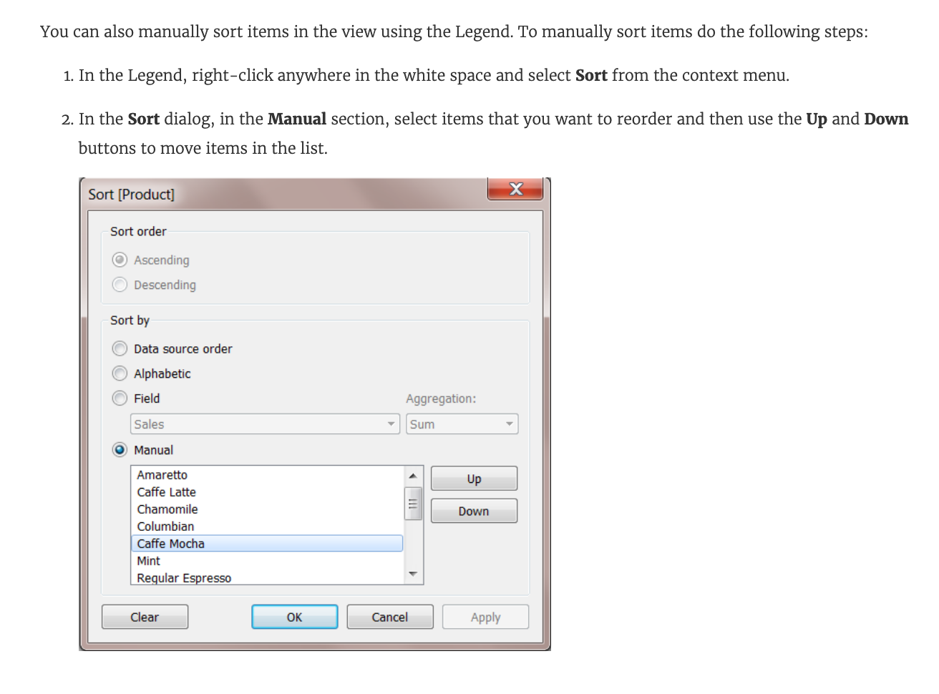

**Reference:** <https://help.tableau.com/current/reader/desktop/en-us/reader_sort.htm>

Bottom of Form

Top of Form

Question 2: **Incorrect**

**Broadly speaking, when users connect to Tableau, the data fields in their data set are automatically assigned a ____________ and a ____________.**

* 

**dimension, measure**

**(Incorrect)**

* 

**ID, Key**

* 

**Data type, Value**

* 

**type, role**

**(Correct)**

**Explanation**

When users connect to Tableau, the data fields in their data set are automatically assigned a **role** and a **type**.

**Role** can be of the following two types:

1) Dimension

2) Measure

**Type** can be of the following :

1) String

2) Number

3) Geographic

4) Boolean

5) Date

6) Date and Time

Bottom of Form

Top of Form

Question 3: **Correct**

**_____________ charts are typically used to represent accumulated totals over time and are the conventional way to display stacked lines.**

* 

**Bullet**

* 

**Area**

**(Correct)**

* 

**Line**

* 

**Gantt**

**Explanation**

According to the official Tableau documentation:

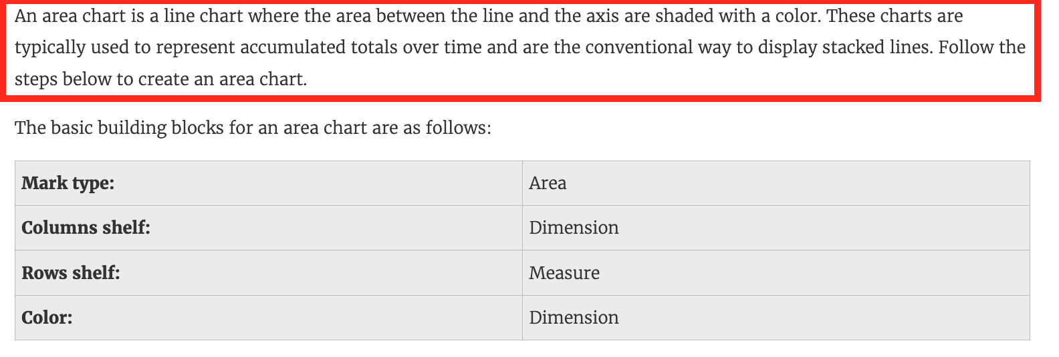

An example of an area chart is shown below:

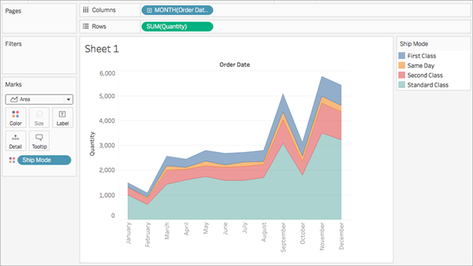

Bottom of Form

Top of Form

Question 4: **Correct**

**When using the manage metadata option, we can create custom names for columns where _____________ is the original name of the column whereas _____________ is the custom name we created in Tableau.**

* 

**Local Name, Actual Name**

* 

**Local Field, Global Field**

* 

**Remote Field Name, Field Name**

**(Correct)**

* 

**Column Name, Actual Name**

**Explanation**

Using the Sample superstore as a reference, click on the manage metadata icon as follows:

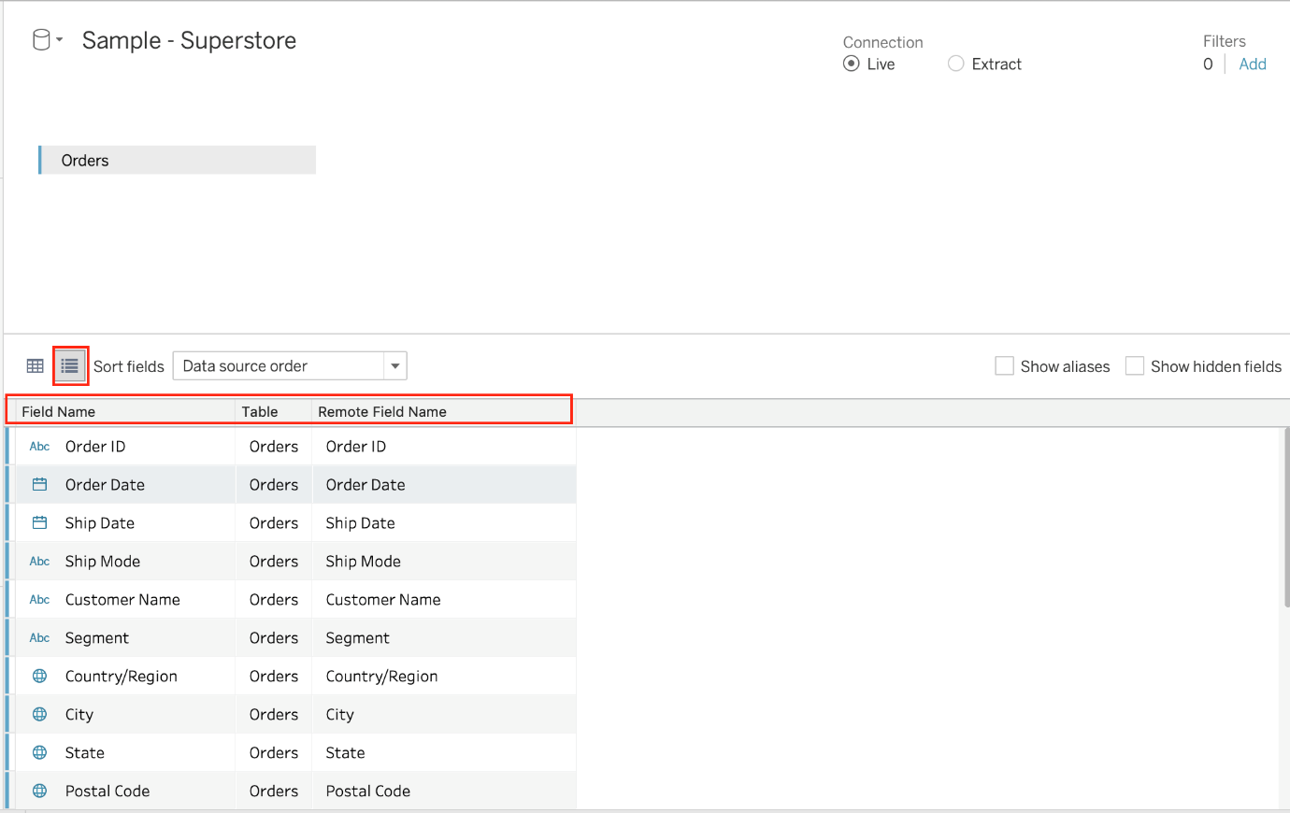

**We can rename a particular column name to make it easier to remember and use in Tableau. Let's change Order ID to oID as shown:**

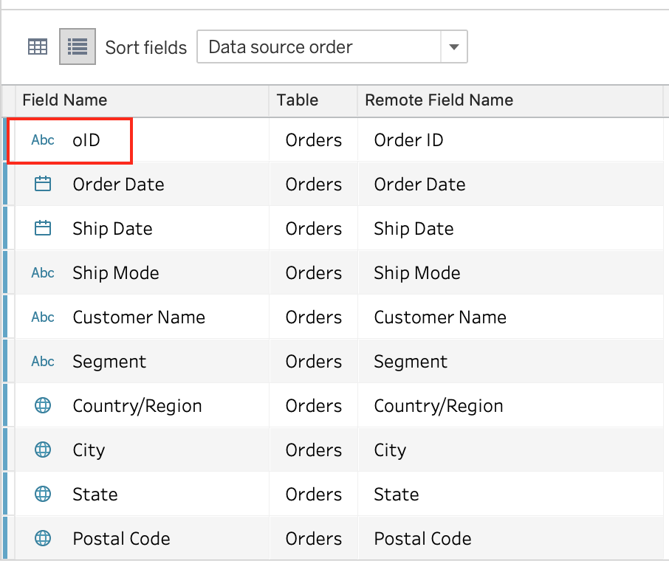

**Now, we'll see oID when using this data source in Tableau. This WILL NOT affect the original data source. The remote field name let's us see what the name of the column is in the ORIGINAL Data source.**

**Reference:** <https://help.tableau.com/current/pro/desktop/en-us/environment_datasource_page.htm#Metadata>

Bottom of Form

Top of Form

Question 5: **Incorrect**

**You may create a context filter to:**

* 

**To create a dependent filter**

**(Incorrect)**

* 

**Create a dependent numerical or top N filter**

**(Correct)**

* 

**To replace a data source filter**

* 

**Improve performance**

**(Correct)**

**Explanation**

Important question! You **cannot** use a context filter to replace a data source filter since each filter type has its own use case. Also, a content filter is an **Independent** filter and all other filters are called dependent since they only process the data that passes through a context filter.

**According to the official documentation :**

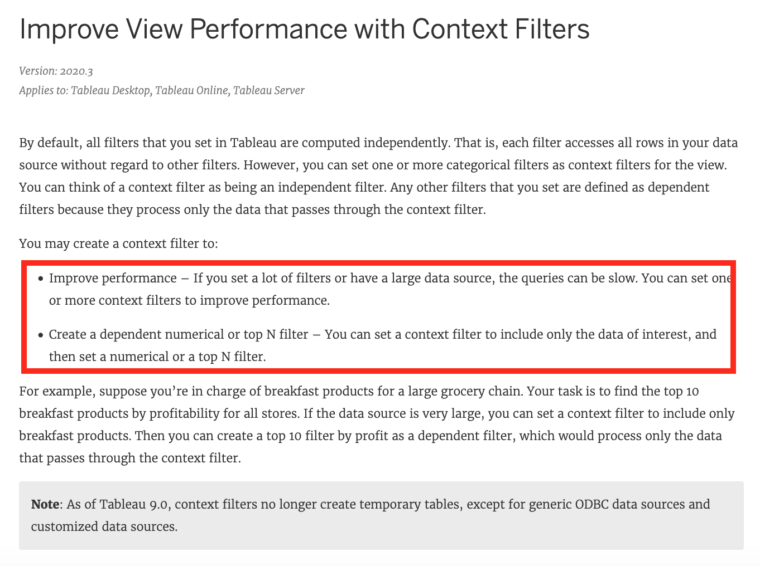

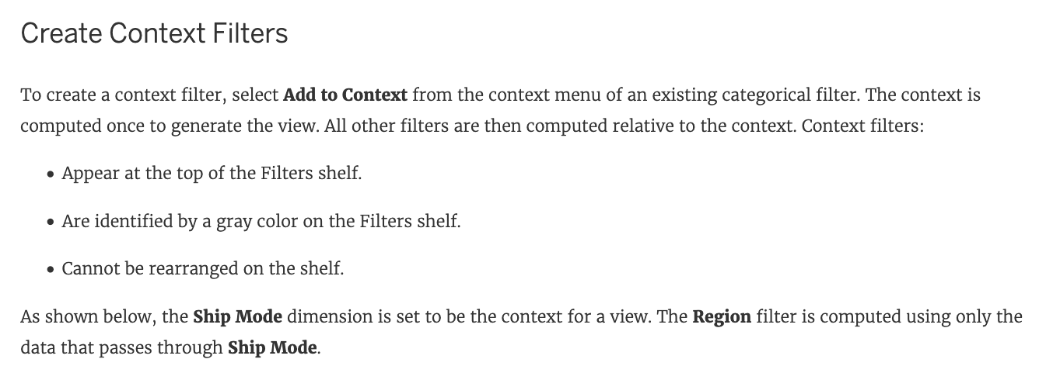



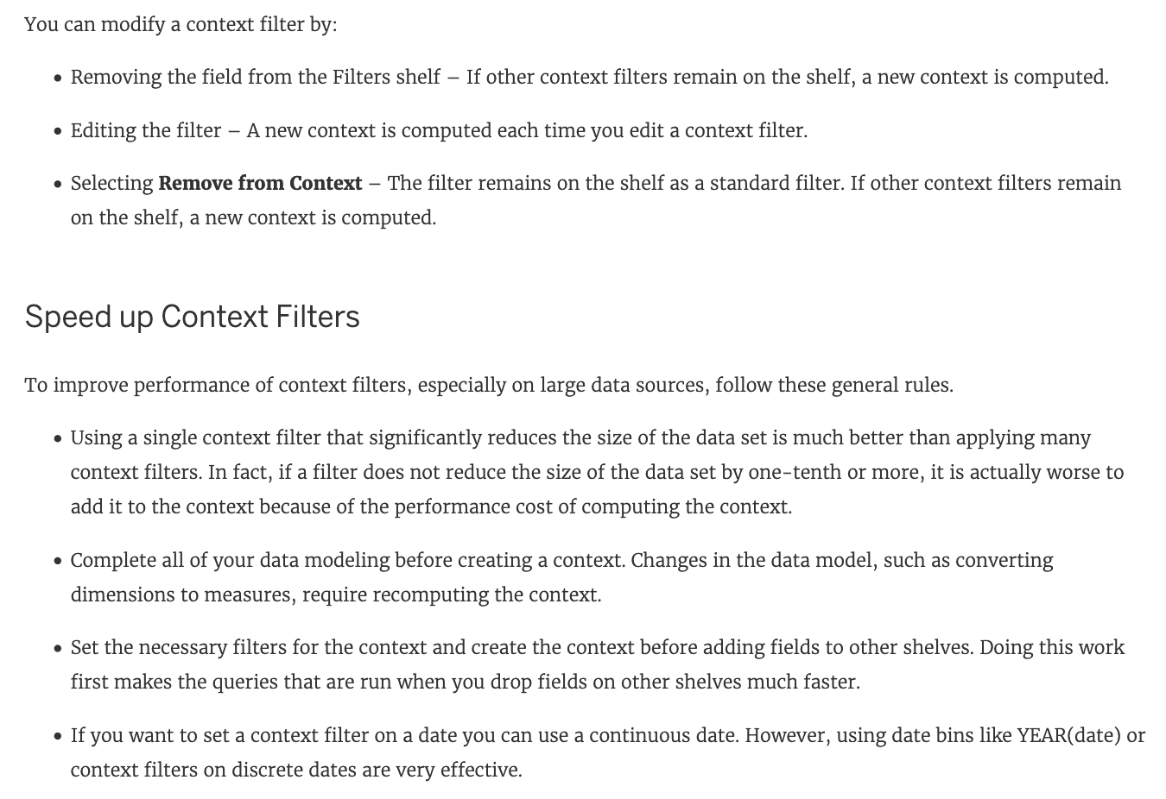

**Reference:** <https://help.tableau.com/current/pro/desktop/en-us/filtering_context.htm>

Bottom of Form

Top of Form

Question 6: **Correct**

**The View Data window displays as much of the data as possible by default, up to _______________ rows.**

* 

**15,000**

* 

**20,000**

* 

**10,000**

**(Correct)**

* 

**5,000**

**Explanation**

The View Data window displays as much of the data as possible by default, up to **10,000 rows. This can be increased though, if you wish to.**

**Read more:**<https://help.tableau.com/current/pro/desktop/en-gb/inspectdata_viewdata.htm>

Bottom of Form

Top of Form

Question 7: **Correct**

**Data blending simulates a traditional _________________ Join**

* 

**Inner**

* 

**Full Outer**

* 

**Left**

**(Correct)**

* 

**Right**

**Explanation**

Data blending simulates a traditional **left** join. The main difference between the two is when the aggregation is performed. **A join combines the data and then aggregates. A blend aggregates and then combines the data.**

**From the official website:**

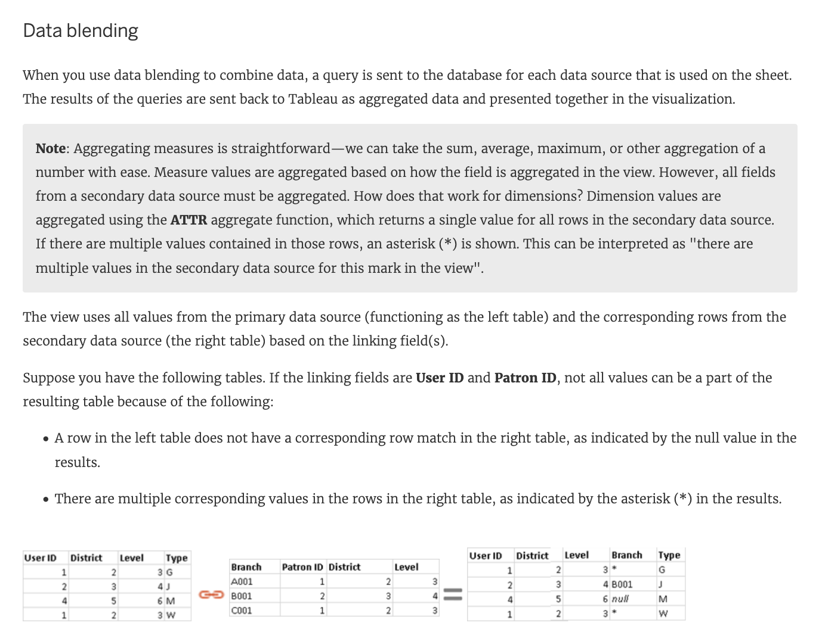

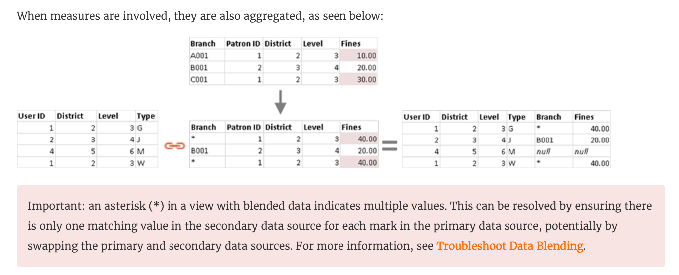

**Reference:**<https://help.tableau.com/current/pro/desktop/en-us/multiple_connections.htm>

Bottom of Form

Top of Form

Question 8: **Incorrect**

**When exporting a worksheet as an image in Tableau, which of the following file formats are available?**

* 

**JPEG Image (.JPG, .JPEG)**

**(Correct)**

* 

**Portable Network Graphic (.PNG)**

**(Correct)**

* 

**Windows Bitmap (.BMP)**

**(Correct)**

* 

**Tagged Image File Format (TIFF)**

**(Incorrect)**

**Explanation**

**The following options are available when an image is Exported:**

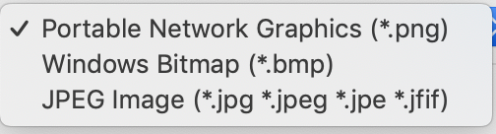

**NOTE:** When we Copy an image rather than exporting it, then the image is copied to the clipboard in the **TIFF** file format! However, it is not available when **EXPORTING** an image.

**Reference:** <https://help.tableau.com/current/pro/desktop/en-us/save_export_image.htm>

Bottom of Form

Top of Form

Question 9: **Correct**

**_________________ is useful when you need to change how the data source is configured on a sheet-by-sheet basis, and when you want to combine databases that don’t allow relationships or joins**

* 

**Union**

* 

**Data Joining**

* 

**Data segregation**

* 

**Data Blending**

**(Correct)**

**Explanation**

**Data blending** is performed on a **sheet-by-sheet basis**and is established when a field from a second data source is used in the view. To create a blend in a workbook already connected to at least two data sources, bring a field from one data source to the sheet—it becomes the primary data source.

Switch to the other data source and use a field on the same sheet—it becomes a secondary data source. An orange linking icon will appear in the data pane, indicating which field(s) are being used to blend the data sources.



**According to the official Tableau Documentation:**

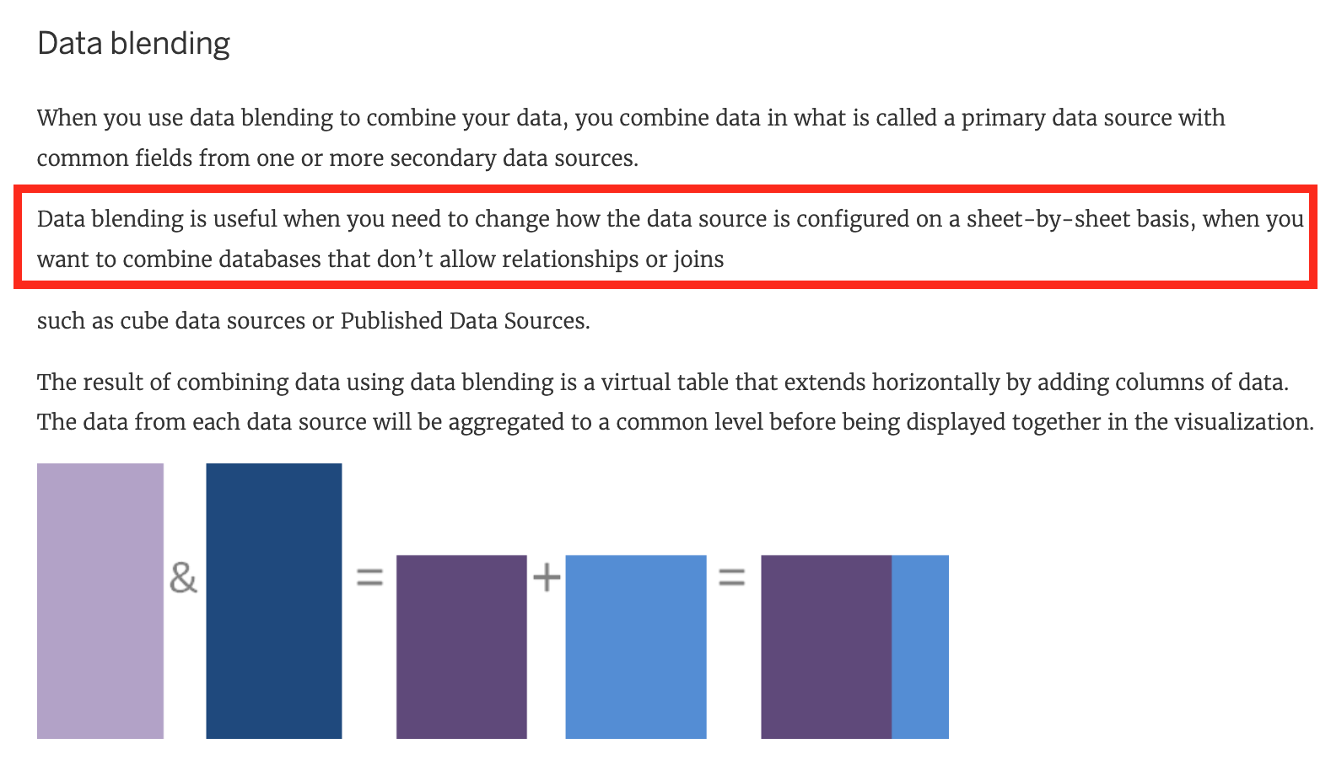

To read more about Data Blending, click on [THIS](https://help.tableau.com/current/pro/desktop/en-us/multiple_connections.htm) link.

Bottom of Form

Top of Form

Question 10: **Correct**

**When using Animations in a Tableau, which of the following is the default duration for animations?**

* 

**0.4s**

* 

**0.2s**

* 

**0.3s**

**(Correct)**

* 

**0.5s**

**Explanation**

**The LATEST Tableau Desktop Sepcialist exam blueprint now requires you to know some basics about animations as well!**



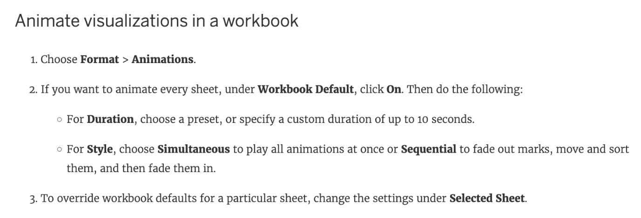

**NOTE: Animations are DISABLED by default and must be manually enabled.**

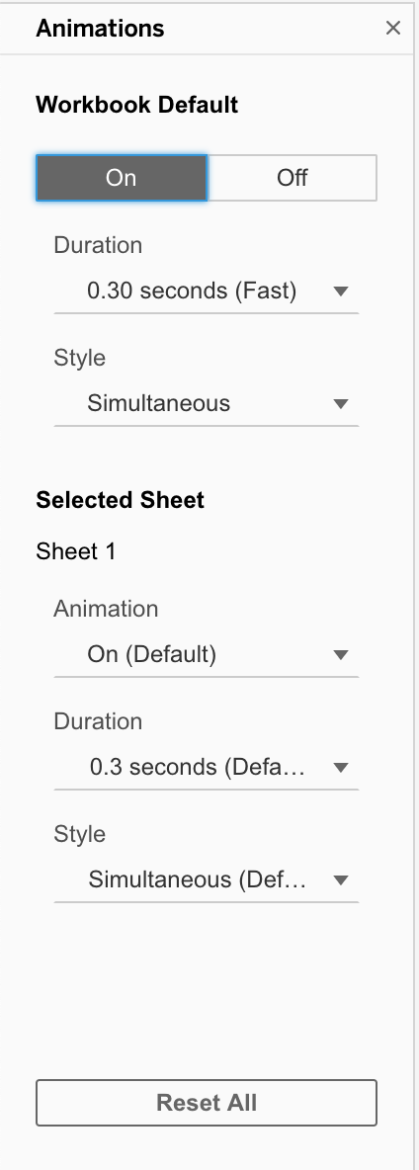

You can also reset all settings to default by clickin on**'Reset All'**

**Reference:** <https://help.tableau.com/current/pro/desktop/en-us/formatting_animations.htm>

Bottom of Form

Top of Form

Question 11: **Correct**

**Which of the following are valid ways to add Totals to a view?**

* 

**Using the Analytics Pane**

**(Correct)**

* 

**Using the Data Pane**

* 

**Using the Marks shelf**

* 

**From the Analysis Tab in the Menu bar on top**

**(Correct)**

**Explanation**

**To add totals to a view using the Analytics pane:**



**Also, you can add totals from the Analytics tab in the Menu above:**

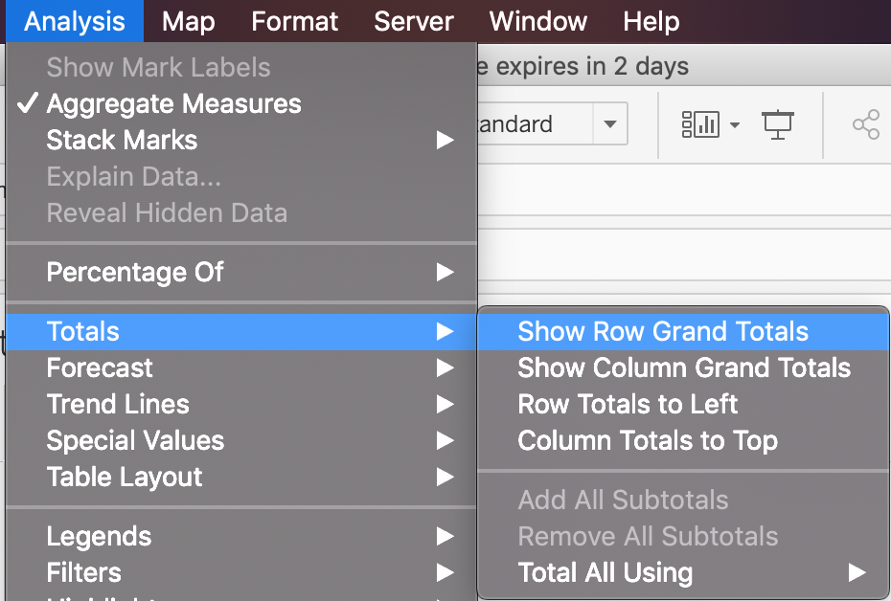

Bottom of Form

Top of Form

Question 12: **Correct**

**Which of these is NOT a type of Quick Filter available in Tableau?**

* 

**Wildcard Match**

* 

**Multiple Values (dropdown)**

* 

**Regex Match**

**(Correct)**

* 

**Single Value (slider)**

**Explanation**

Upon clicking on a filter, we see the following options:

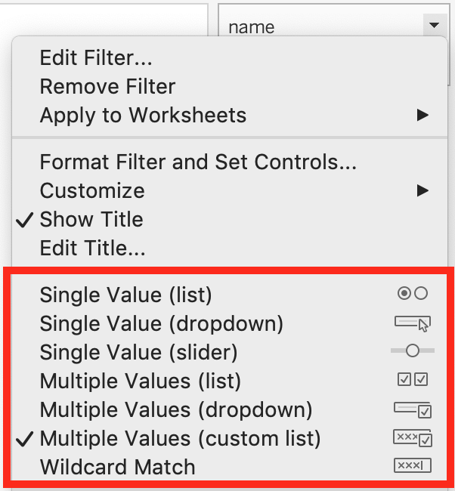

Clearly, **Regex Match**is not one of these options!

Bottom of Form

Top of Form

Question 13: **Correct**

**Which of the following are valid ways to show Mark Labels in the visualisation?**

* 

**Click on Data in the Menu bar and Choose Show Mark Labels**

* 

**Click on the Show mark labels icon in the Toolbar**

**(Correct)**

* 

**Drag the measure to the Text label in the Marks Card**

**(Correct)**

* 

**Click on Analysis in the Menu bar and choose Show Mark Labels**

**(Correct)**

**Explanation**

The following showcase how you can show mark labels. Using the Sample Superstore dataset:

**1) Let's create a Bar chart showing the sales for each sub-category:**

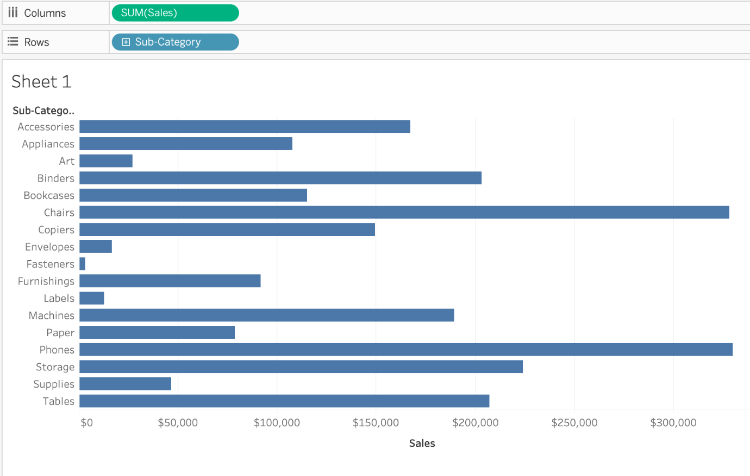

**2) Now you can show labels by:**

2.1) Click on Show Mark Labels Icon in the Toolbar**( easiest )**

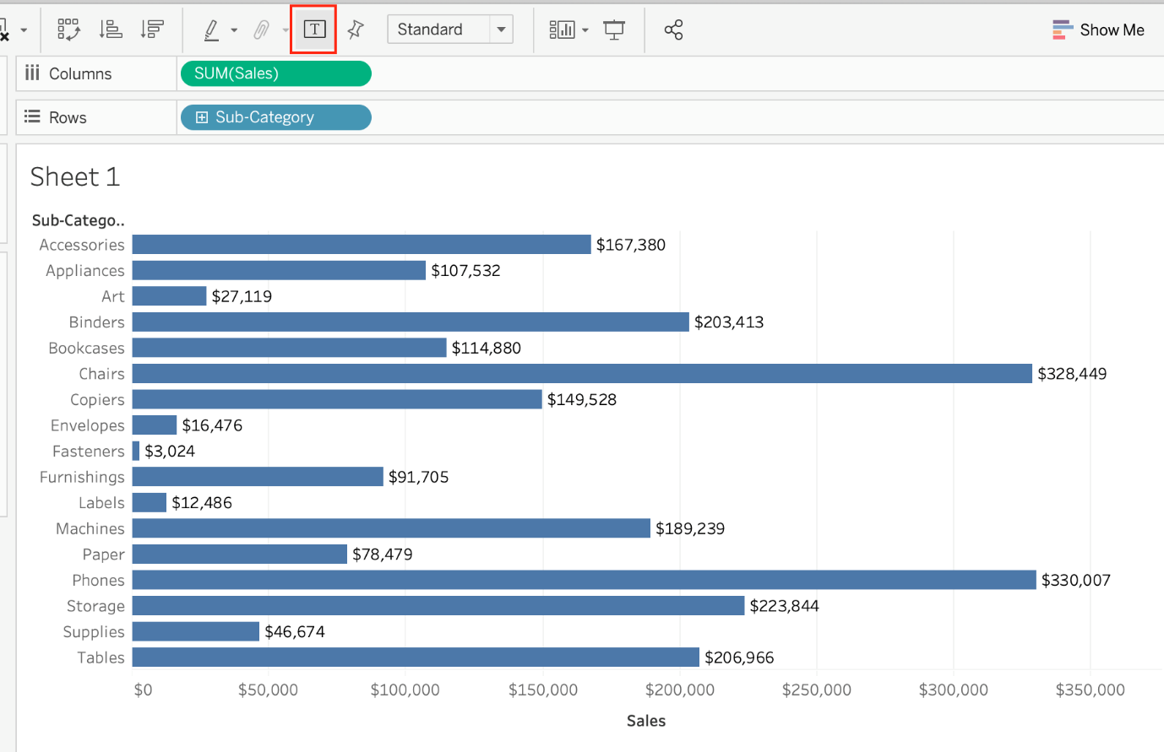

**2.2) Drag Sales to the Text icon in the Marks Card:**

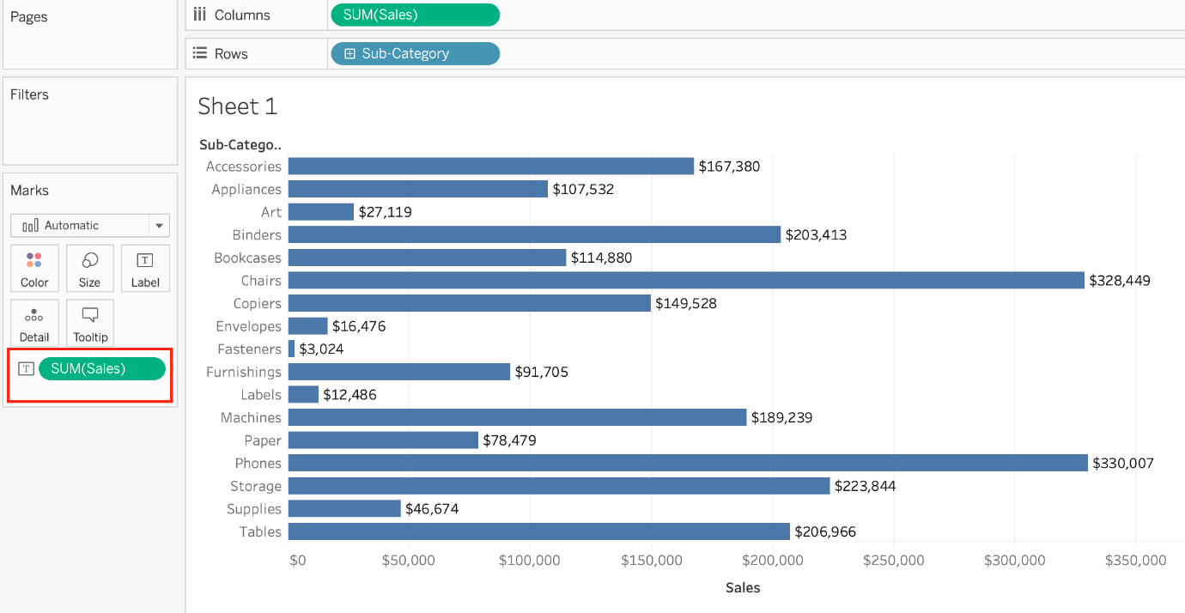

**2.3) Click on Analysis -> Show mark labels from the Tableau menu bar:**

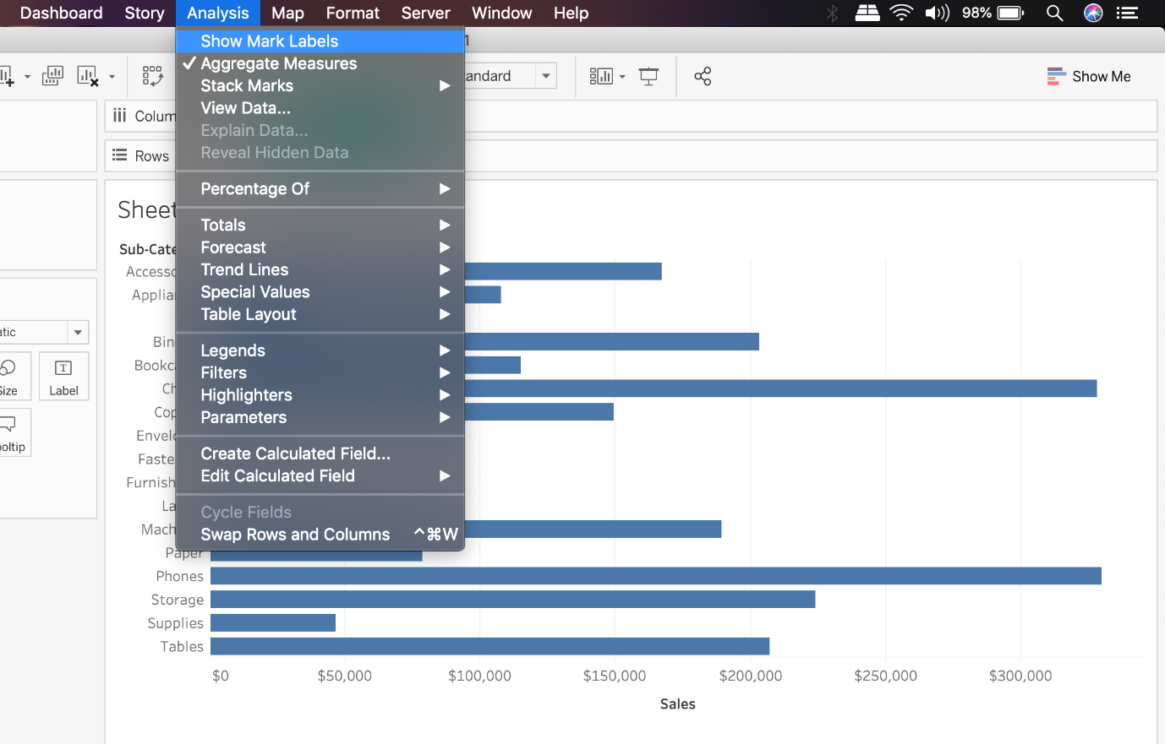

Bottom of Form

Top of Form

Question 14: **Correct**

**You want to add Custom shapes to your visualisation. Where can you add these new shapes?**

* 

**In Downloads -> My Tableau Repository -> Shapes**

* 

**In My Documents -> My Tableau Repository -> Shapes**

**(Correct)**

* 

**In My Computer -> C: -> Tableau -> Shapes**

* 

**In Program Files -> Tableau  -> Shapes**

**Explanation**

**Here's how to add image files to your repository:**

1) Find image file on the internet. I try to find consistent image formats if I plan to use a set of shapes such as logos or flags.

2) Download the image to your computer.

3) Drag images into your **My Documents -> My Tableau repository -> Shapes** folder.

4) Open Tableau and your new shapes will automatically be included in your **"edit shapes"** menu.

**Reference:** <https://www.tableau.com/about/blog/2016/2/how-use-custom-shapes-filters-your-dashboard-50200>

Bottom of Form

Top of Form

Question 15: **Correct**

**How can you format numbers in Tableau as currency?**

* 

**Right-click a measure or axis in the view and select Format. Then in the Format pane, click the Numbers drop-down menu.**

**(Correct)**

* 

**Right-click on the Sheet name and select Format. Then in the Format pane, click the Numbers drop-down menu.**

* 

**Right-click on the data source used in the view and select Format. Then in the Format pane, click the Numbers drop-down menu.**

* 

**Right-click a dimension in the view and select Format. Then in the Format pane, click the Numbers drop-down menu.**

**Explanation**

**According to the official Tableau documentation:**

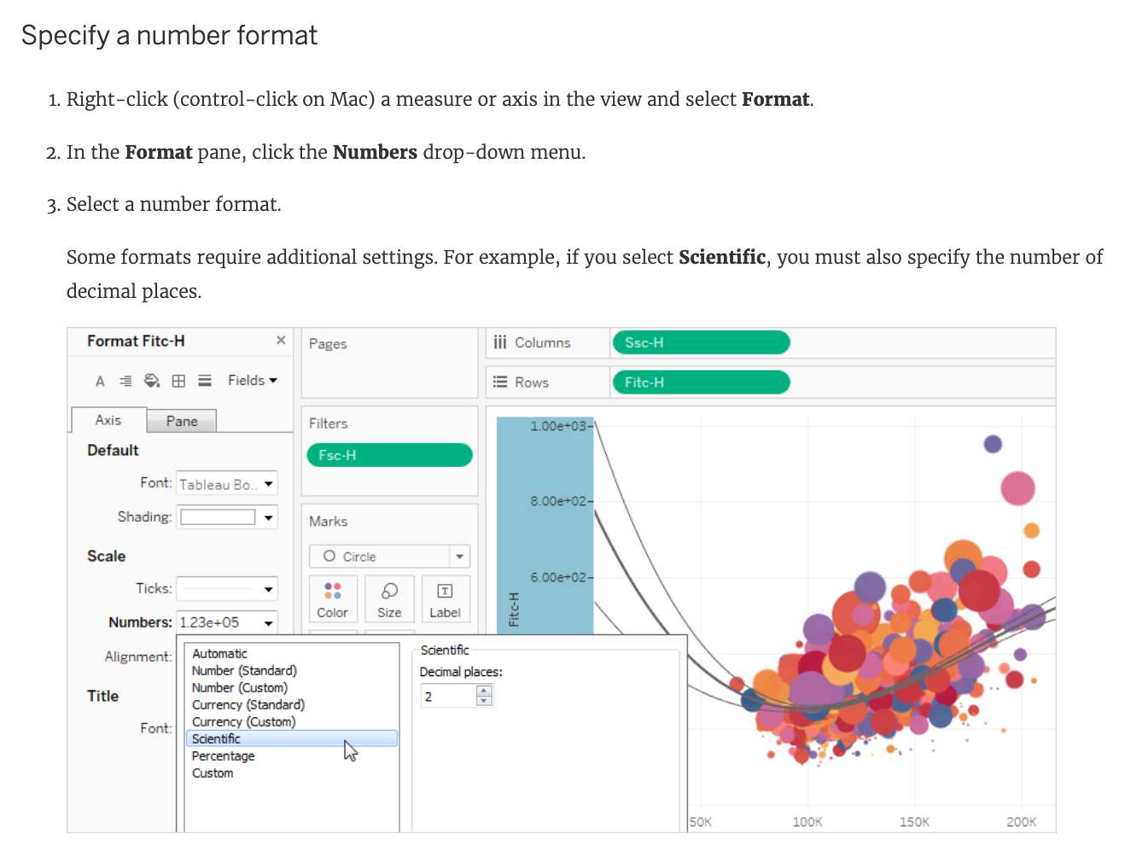

**Reference:**<https://help.tableau.com/current/pro/desktop/en-us/formatting_specific_numbers.htm>

Bottom of Form

Top of Form

Question 16:

**Skipped**

**What is the one critical difference between normal calculated fields, and the calculated fields created after Data blending?**

* 

**The calculated fields created in Blends cannot use more than 2 fields**

* 

**Fields used in Blends must first be aggregated**

**(Correct)**

* 

**No difference, calculated fields cannot be created in Blends**

* 

**The calculated fields created in Blends cannot be edited once created**

**Explanation**

Yes, due to the nature of blends, there are some conditions as follows from the official documentation that must be kept in mind while working with blends:

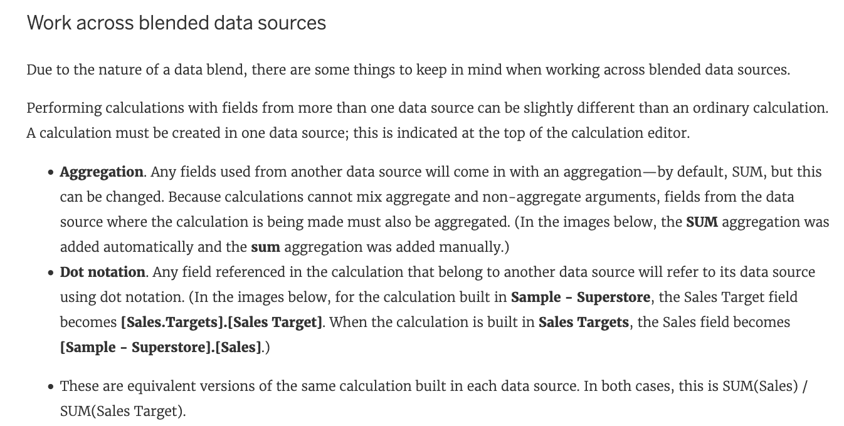

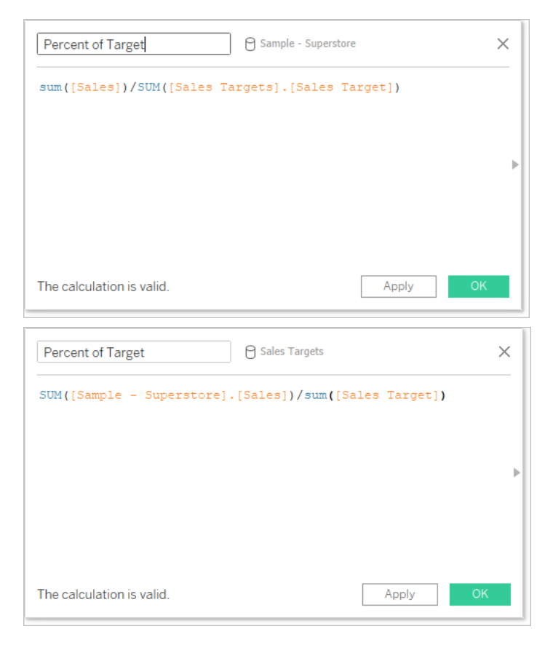

In addition to handling calculations slightly differently, there are some limitations on secondary data sources. You may not be able to sort by a field from a secondary data source, and action filters may not work as expected with blended data. For more information, see [Other data blending issues](https://help.tableau.com/current/pro/desktop/en-us/multipleconnections_troubleshooting.htm#other).

**Reference:** <https://help.tableau.com/current/pro/desktop/en-us/multiple_connections.htm>

Bottom of Form

Top of Form

Question 17: **Correct**

**To connect Tableau to a CSV data source what type of connection should you use?**

* 

**JSON**

* 

**Excel**

* 

**Text**

**(Correct)**

* 

**Spatial**

**Explanation**

Tableau recognises a **CSV file as a TEXT file,** and therefore it is the correct option.

The following are the steps to import a CSV file:

1) From the data connection screen, click on Text:

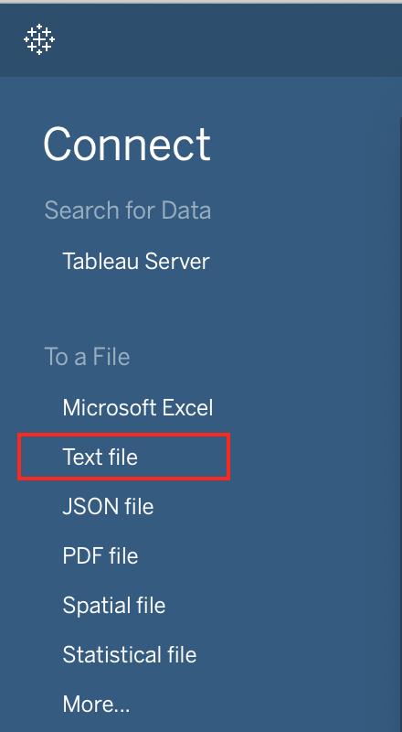

2) Choose the appropriate file, and click Open:

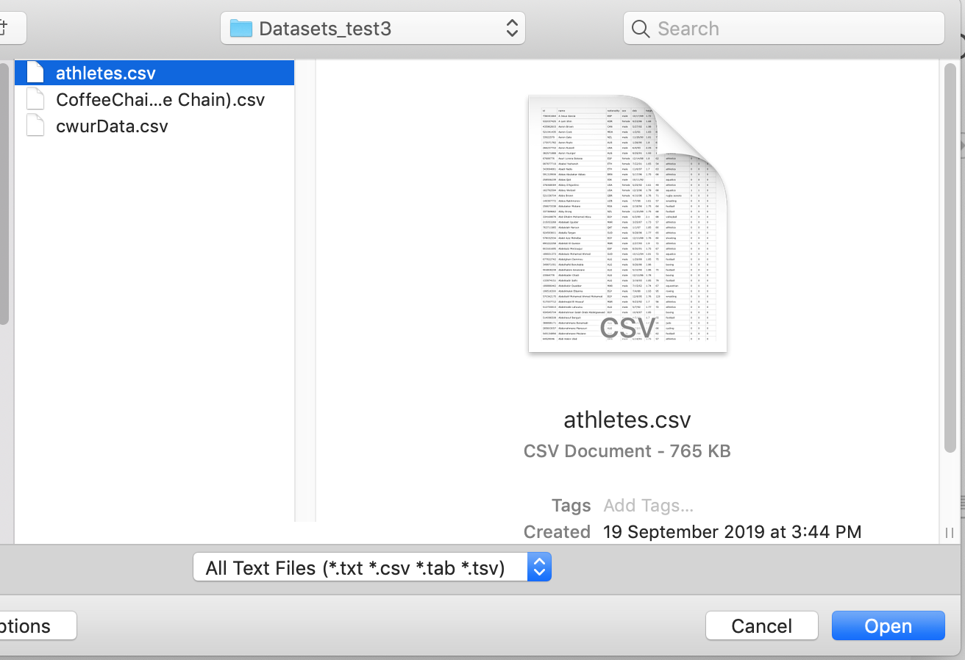

3) Finally, Tableau imports the data as shown below:

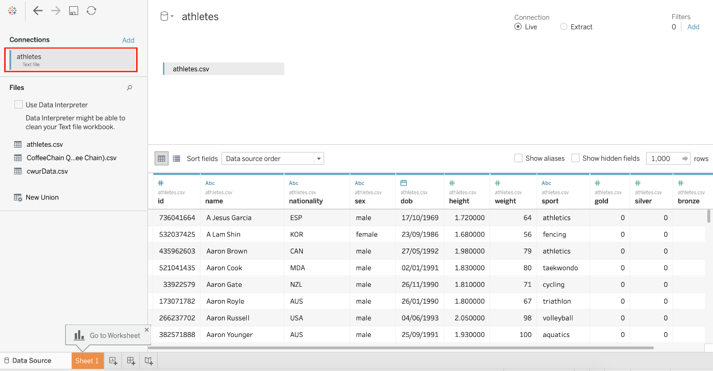

**Reference:** <https://intellipaat.com/community/46338/how-to-import-csv-file-in-tableau>

Bottom of Form

Top of Form

Question 18: **Correct**

**How can you change the default Tableau repository location?**

* 

**By clicking on Window -> Repository Location**

* 

**By clicking on File -> Repository Location and choosing a new location**

**(Correct)**

* 

**By clicking on Help -> Change Repository Location**

* 

**By Moving the repository location manually to wherever we want**

**Explanation**

**According to the official Tableau documentation:**

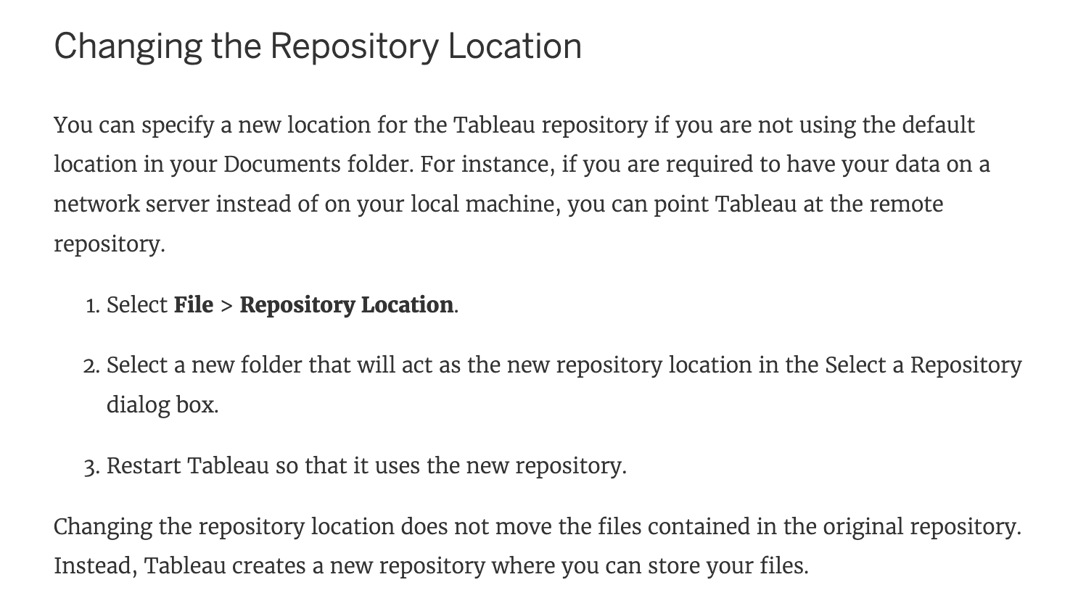

**Reference:** <https://help.tableau.com/current/pro/desktop/en-us/environ_filesandfolders.htm>

Bottom of Form

Top of Form

Question 19: **Correct**

**______________ is a method for appending values (rows) to tables. You can use this method if both tables have the same columns. The result is a virtual table that has the same columns but extends vertically by adding rows of data.**

* 

**Blending**

* 

**Unioning**

**(Correct)**

* 

**Joining**

* 

**Combining**

**Explanation**

Unioning is the correct answer!

**From the official documentation:**

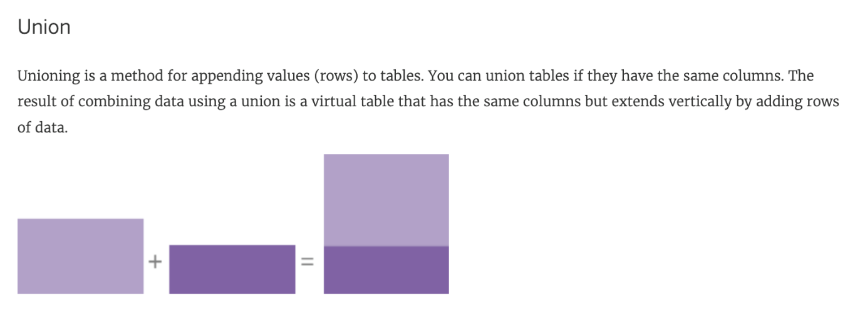

For example, suppose you have the following customer purchase information stored in three tables, separated by month. The table names are "May2016" , "June2016" and "July2016."

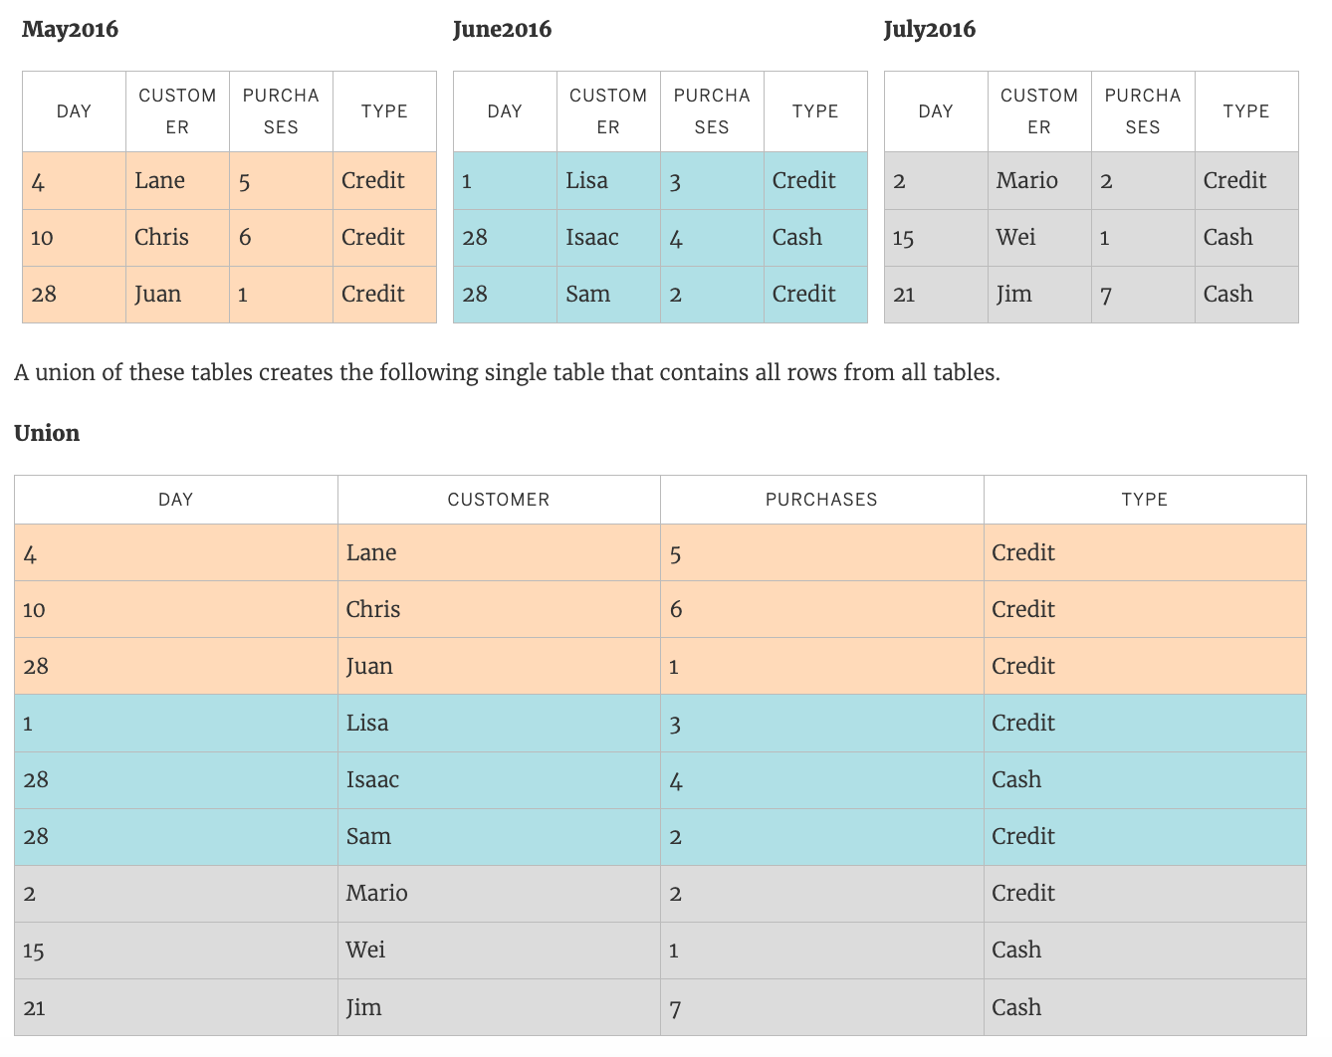

**Reference:**<https://help.tableau.com/current/pro/desktop/en-us/union.htm>

Bottom of Form

Top of Form

Question 20: **Correct**

**________________ can only create header. _______________ will create header and axis both.**

* 

**Groups, Sets**

* 

**Measures, Dimensions**

* 

**Dimensions, Measures**

**(Correct)**

* 

**Dates, Strings**

**Explanation**

**Using the Sample superstore as a reference:**

1) Let's plot a bar chart showing SUM(Quantity) for each Segment:

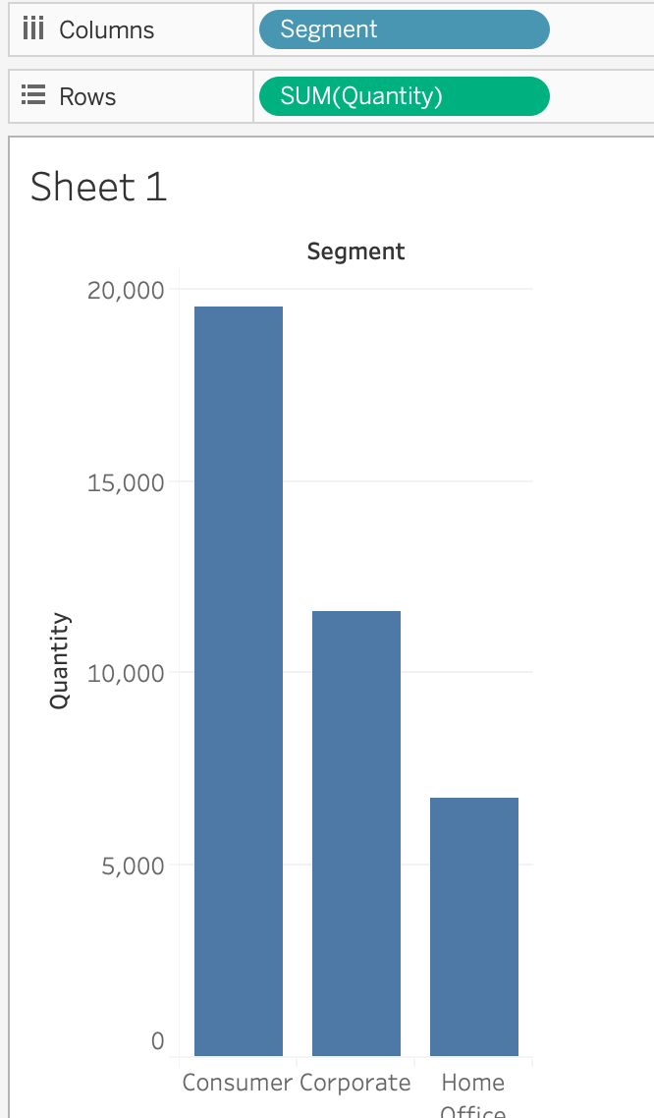

**2) Right click on the x-axis (Segment):**

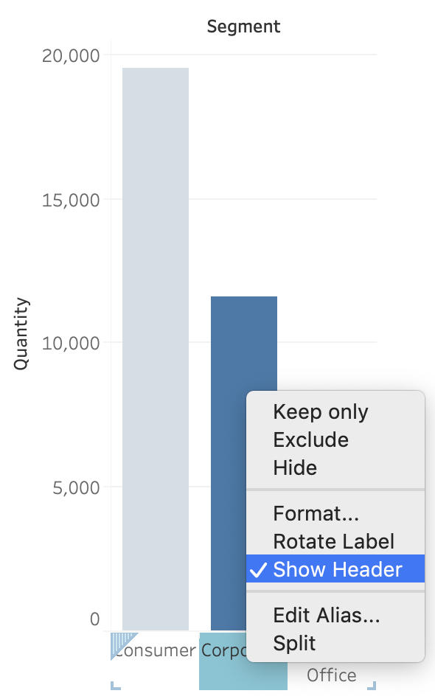

Notice we don't have an option to edit the axis, only header. This is because only **continous** values form the **AXIS**.

**3) Similarly, right click on the y-axis (Quantity):**

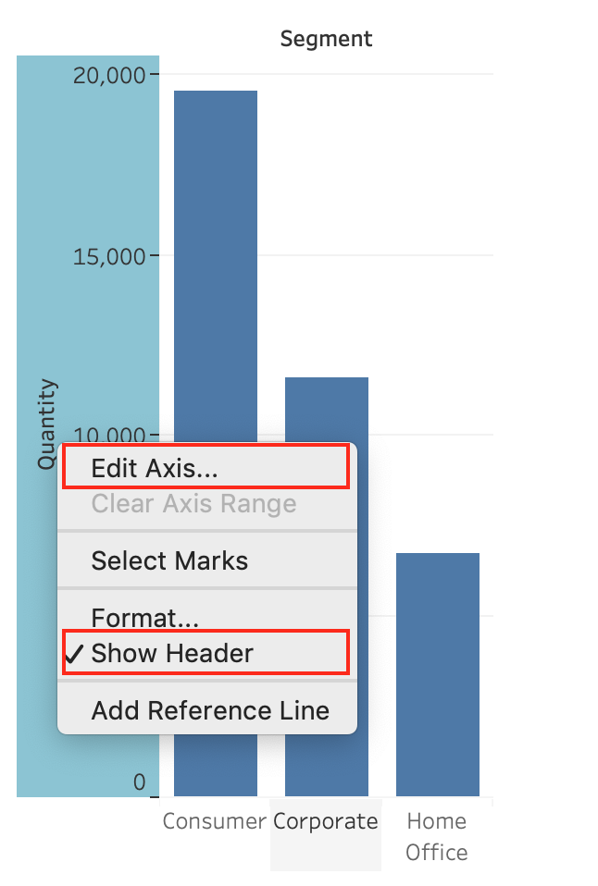

**Now we have the option to edit BOTH the axis and the header.**

**Reference:** <https://help.tableau.com/current/pro/desktop/en-us/view_parts.htm>

Bottom of Form

Top of Form

Question 21: **Correct**

**Dragging a ______________ to colour creates distinct colours for each item whereas dragging a ______________ to colour creates a gradient**

* 

**Geographic Value, Discrete Value**

* 

**Discrete value, Continuous Value**

**(Correct)**

* 

**Continuous Value, Discrete Value**

* 

**Longitude, Latitude**

**Explanation**

Remember that dragging a **discrete** value to colour creates **distinct** colours for each item whereas dragging a **continuous** value to colour creates a **gradient**. ( Same for Map )

**From the official documentation:**

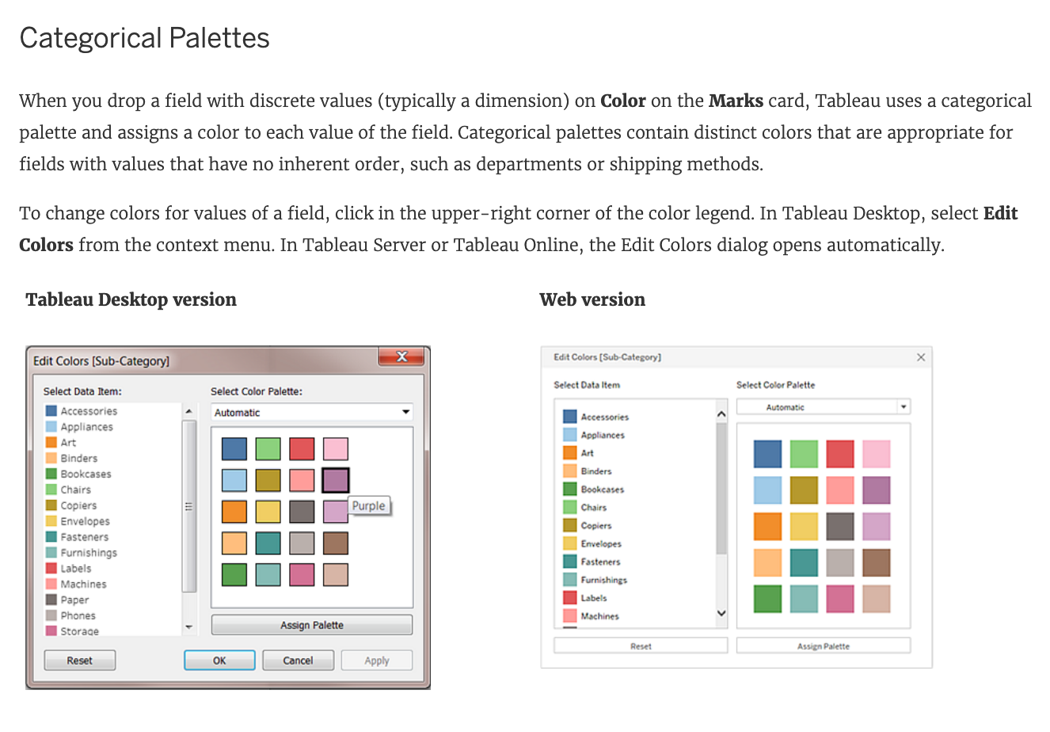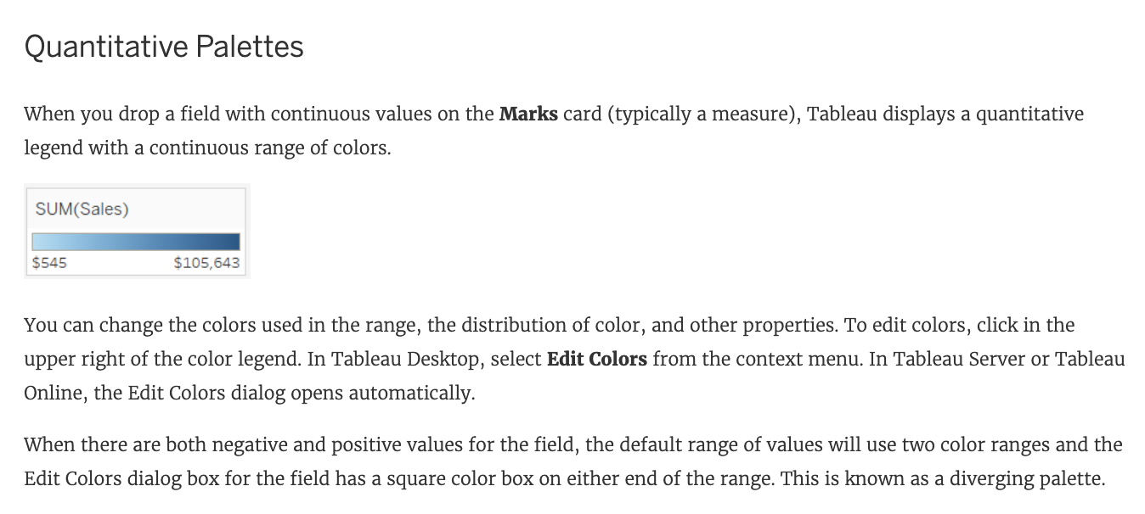

**Reference:**<https://help.tableau.com/current/pro/desktop/en-us/viewparts_marks_markproperties_color.htm>

Bottom of Form

Top of Form

Question 22: **Correct**

**Which of the following are correct ways to define a join in Tableau version 2020.3 and above?**

* 

**Right-click a logical table and click on open to go to the Join/Union canvas in the physical layer and add joins or unions.**

**(Correct)**

* 

**Double-click a physical table to go to the Join/Union canvas in the logical layer and add joins or unions.**

* 

**Right-click a physical table and click on open to go to the Join/Union canvas in the logical layer and add joins or unions.**

* 

**Double-click a logical table to go to the Join/Union canvas in the physical layer and add joins or unions.**

**(Correct)**

**Explanation**

Remember that joins are defined in the physical layer and relationships in the logical layer.

You can still specify joins between tables in the physical layer of a data source. Double-click a logical table to go to the Join/Union canvas in the physical layer and add joins or unions.

Every top-level, logical table contains at least one physical table. Open a logical table to view, edit, or create joins between its physical tables. Right-click a logical table, and then click **Open**. Or, just double-click the table to open it.



When you create a data source, it has two layers. The top-level layer is the logical layer of the data source. You combine data between tables in the logical layer using relationships.

The next layer is the physical layer of the data source. You combine data between tables at the physical layer using joins. For more information, see [Logical and physical tables in the data model](https://help.tableau.com/v2020.2/pro/desktop/en-us/datasource_datamodel.htm)

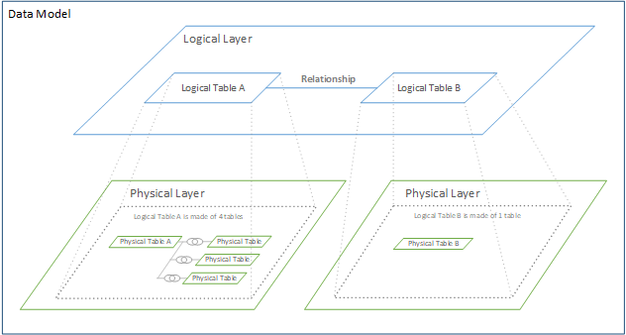

**Reference:** <https://help.tableau.com/current/online/en-us/datasource_relationships_learnmorepage.htm>

Bottom of Form

Top of Form

Question 23: **Correct**

**According to Tableau's 'Order of Operations', which of the following filters is applied FIRST?**

* 

**Context Filter**

* 

**Extract Filter**

**(Correct)**

* 

**Dimension Filter**

* 

**Measure Filter**

**Explanation**

According to Tableau's order of operations, the **Extract** **filter** is right at the top of the hierarchy. The data filtered in the Extract is then passed on to what we see in the Data Pane. See below:

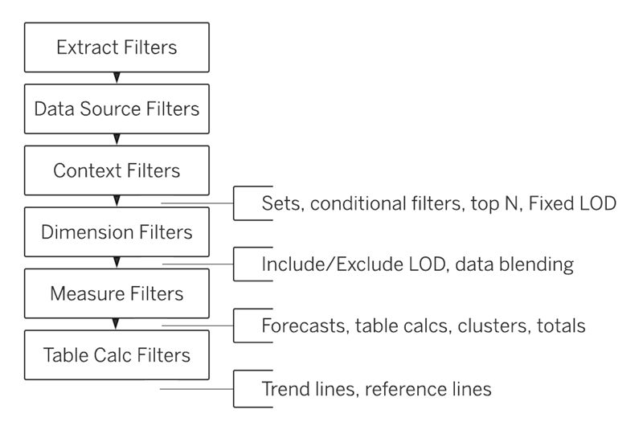

**Reference:**<https://help.tableau.com/current/pro/desktop/en-us/order_of_operations.htm>

Bottom of Form

Top of Form

Question 24: **Correct**

**Yes or No: The number of marks will increase when you increase the number of Dimensions in a view**

* 

**Yes**

**(Correct)**

* 

**No**

**Explanation**

Of course! As an example, see below:

1) Using the Sample Superstore data, let's plot a bar chart showing the Sales for each Category:

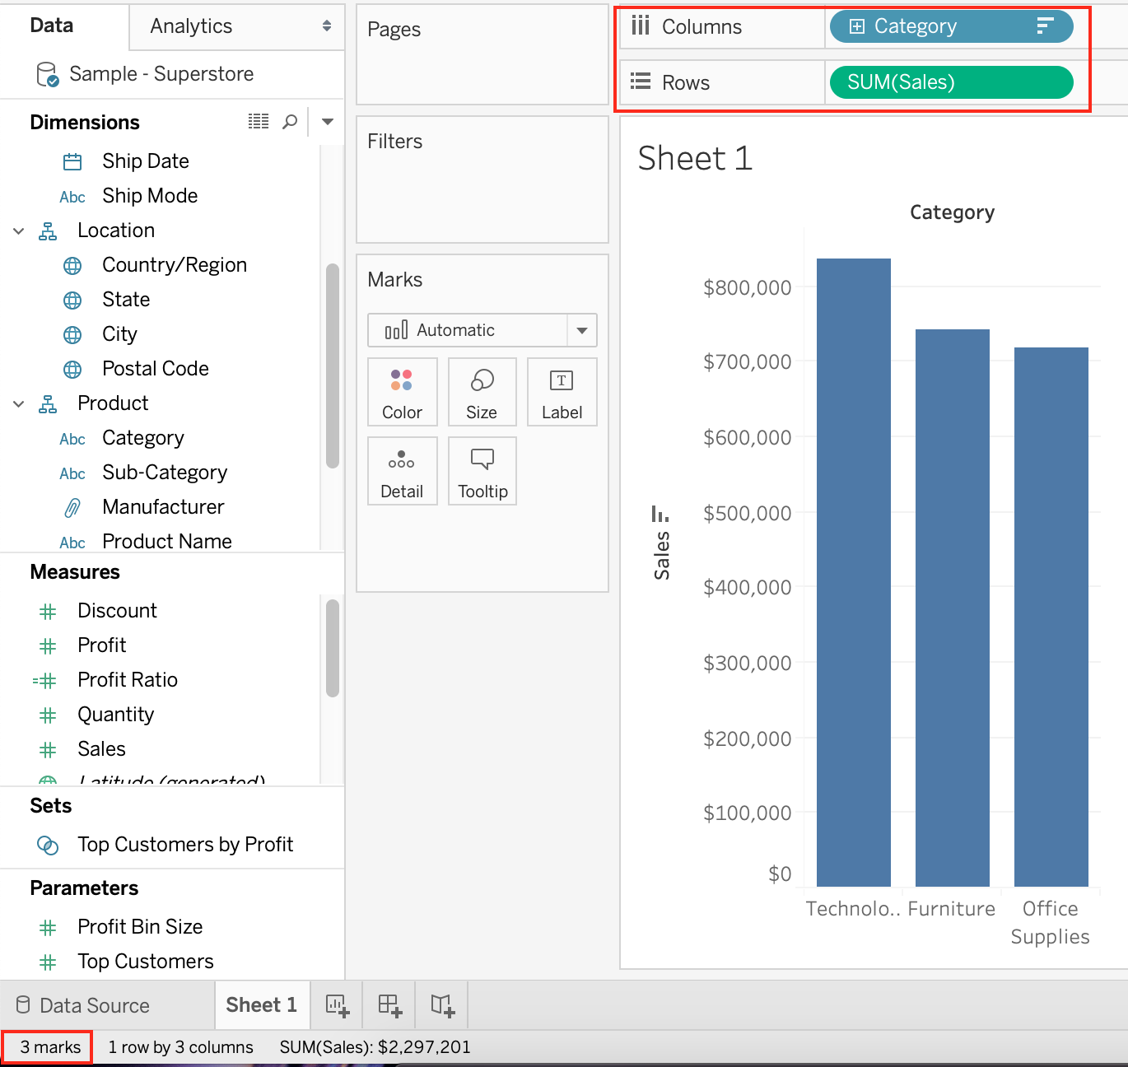

Observe that we have **3 marks** - **Each bar in a bar chart is called a mark. Similarly, each point in a scatter plot is also a mark , and so on for all charts.**

**1 row by 3 columns** means that clearly on the y-axis (Sales), we have only a single mark - a single continous axis, but 3 different marks (Technology, Furniture and Office supplies ) on the x-axis.

2) Now let's add subcategory to the view as well **(another dimension):**

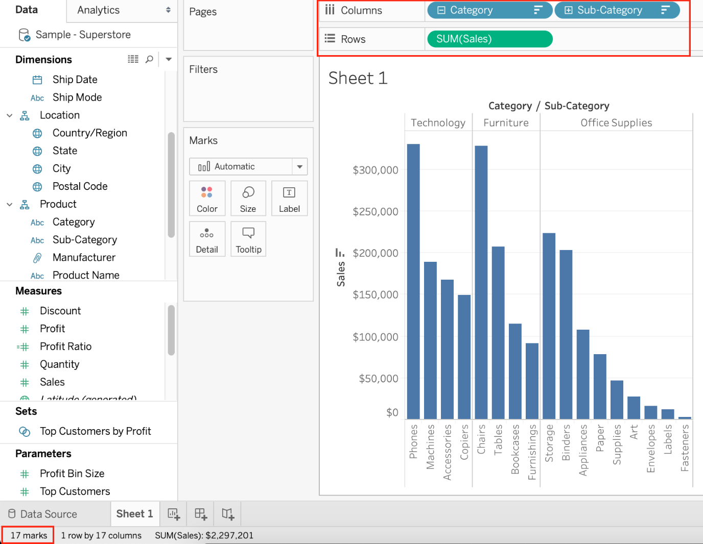

**Observe that the number of marks has increased - i.e the number of Bars.**

Also, notice we now have **1 row and 17 columns.** Simply because 1 row = Sales (on the y-axis), and on the x-axis, we have 17 different columns (i.e product sub categories!!)

Bottom of Form

Top of Form

Question 25: **Correct**

**Which of the following would you use to edit the Shape, colour, and Text of your visualisations?**

* 

**Filter Shelf**

* 

**Data Pane**

* 

**Analytics Pane**

* 

**Marks Card**

**(Correct)**

**Explanation**

The Marks Card allows us not only to edit the **Shape, Text and Colour**, but also to modify the **Tooltip** and the **level of detail**of the visualisation!

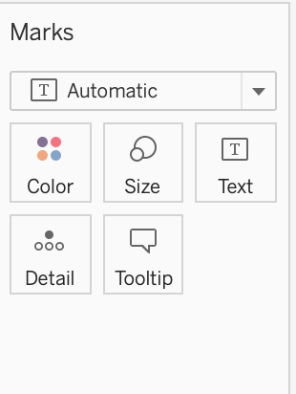

The **Marks card** is a key element for visual analysis in Tableau. As you drag fields to different properties in the Marks card, you add context and detail to the marks in the view.

You use the Marks card to set the mark type (see [Change the Type of Mark in the View](https://help.tableau.com/current/pro/desktop/en-us/viewparts_marks_marktypes.htm)), and to encode your data with color, size, shape, text, and detail. To change the mark settings, see [Control the Appearance of Marks in the View](https://help.tableau.com/current/pro/desktop/en-us/viewparts_marks_markproperties.htm).

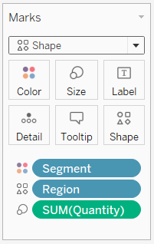

In this example, three different fields have been dragged to different **properties** in the Marks card. Segment is on Color, Region is on Shape, and Quantity is on Size.

After you add a field to the Marks card, you can click the icon next to the field to change the property it is using. You can also click the property buttons in the Marks card to change those settings.

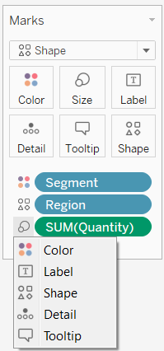

Many properties can have multiple fields. For example, you can add multiple fields to Label, Detail, Tooltip, and Color. Size and Shape can only have one field at a time. For more details, see [Control the Appearance of Marks in the View](https://help.tableau.com/current/pro/desktop/en-us/viewparts_marks_markproperties.htm).

**Reference:**<https://help.tableau.com/current/pro/desktop/en-us/buildmanual_shelves.htm>

Bottom of Form

Top of Form

Question 26: **Correct**

**A _____________ action is a hyperlink that points to a web page, file, or other web-based resource outside of Tableau.**

* 

**Go to URL**

**(Correct)**

* 

**Go to Hyperlink**

* 

**Go to Web page**

* 

**Go to Sheet**

**Explanation**

Tricky options! Go to hyperlink and Go to Web page are not valid Actions in Tableau.

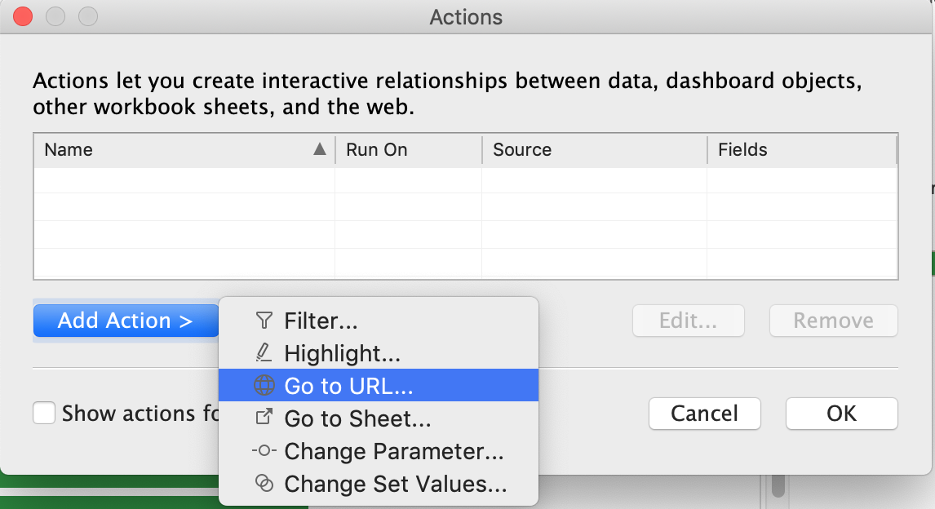

**A URL action** is a hyperlink that points to a web page, file, or other web-based resource outside of Tableau. You can use URL actions to create an email or link to additional information about your data. To customize links based on your data, you can automatically enter field values as parameters in URLs.

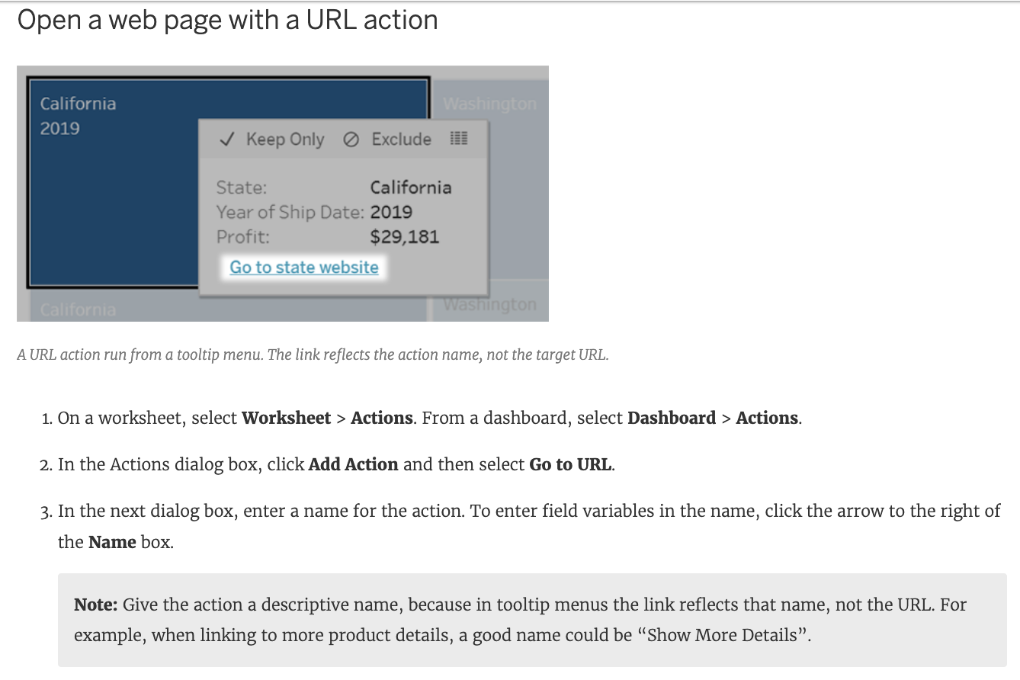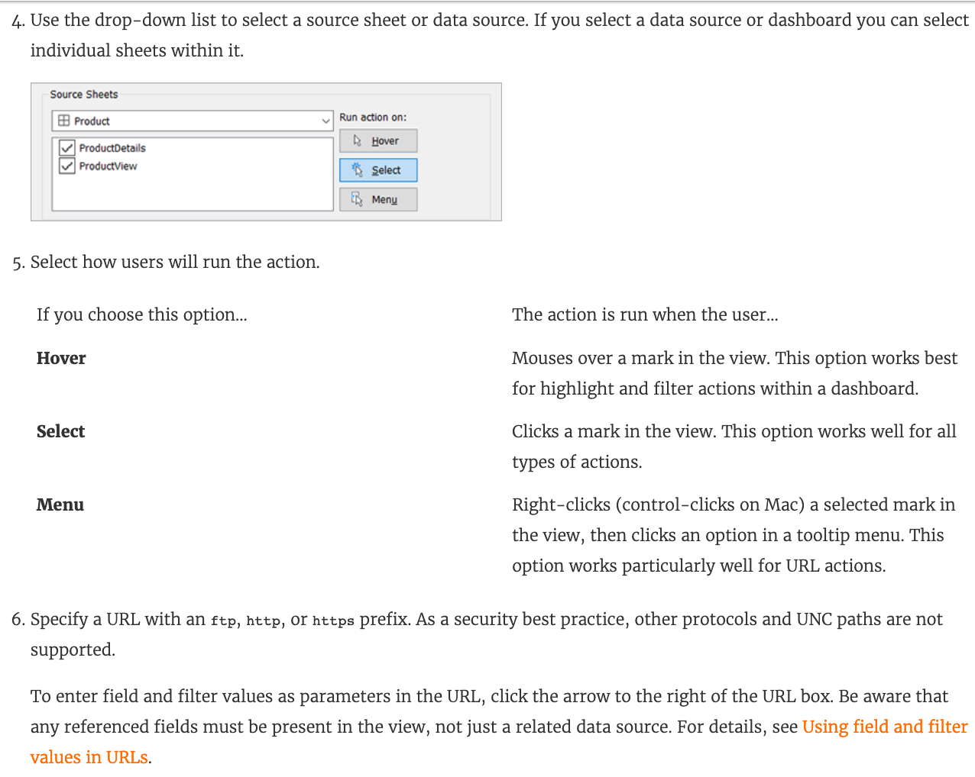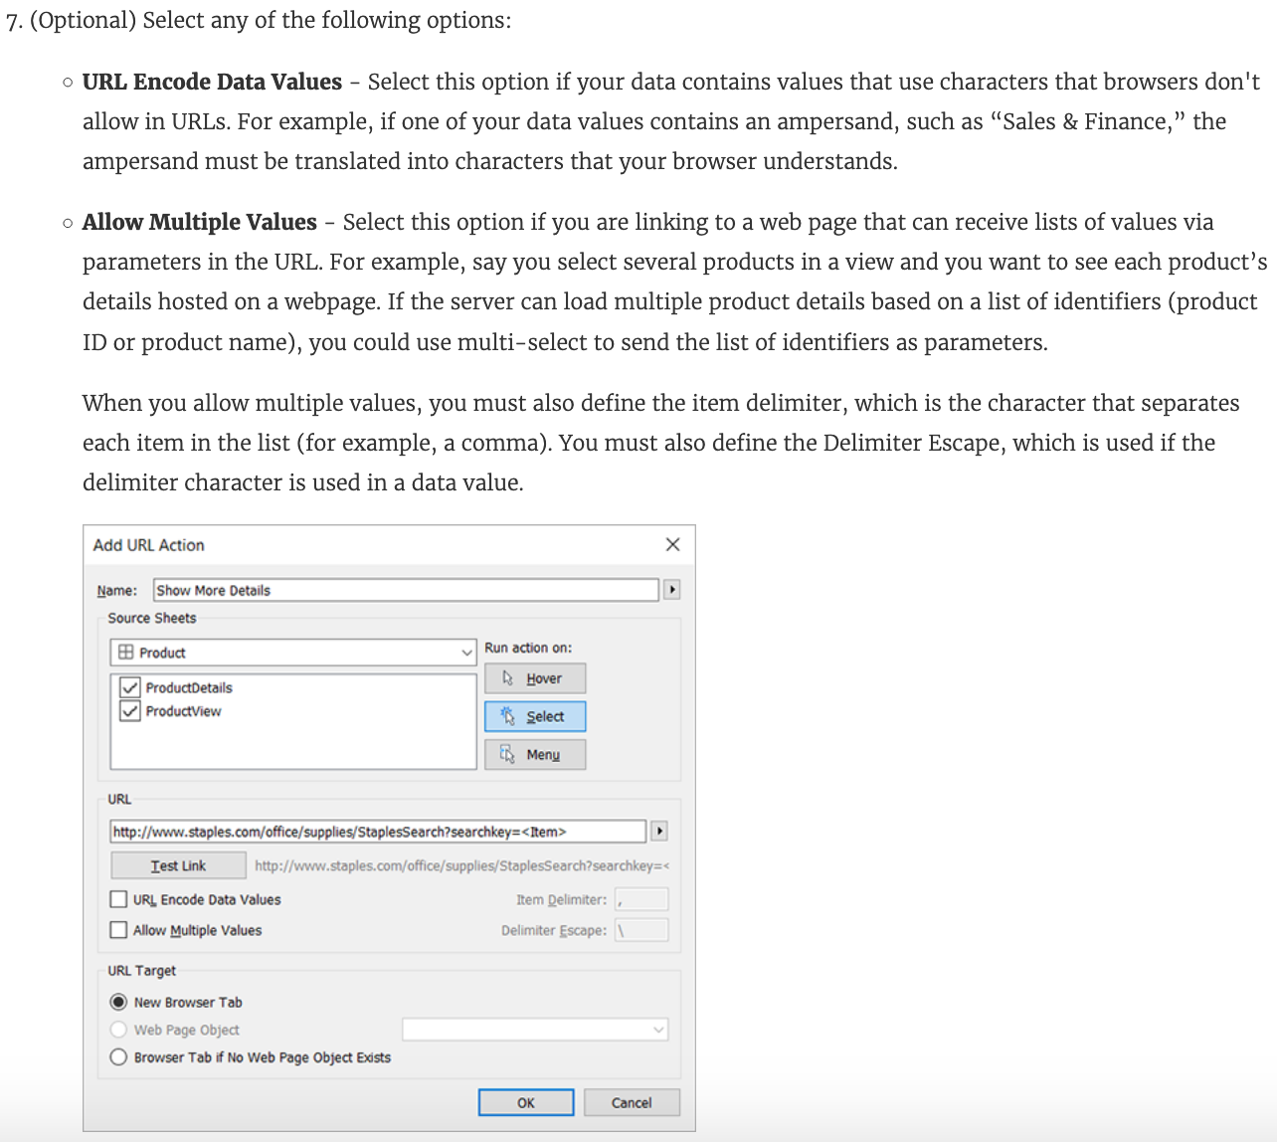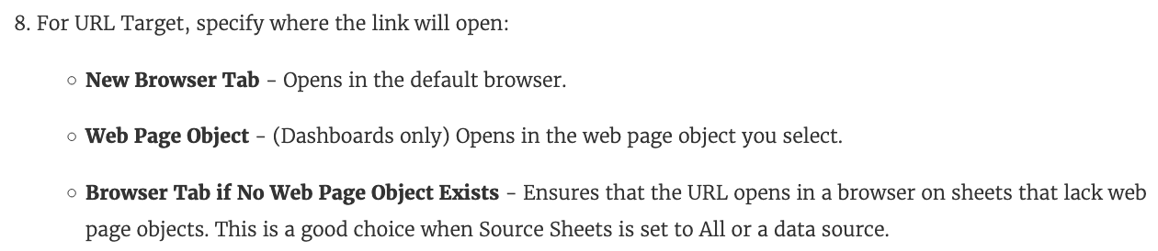

**Reference:** <https://help.tableau.com/current/pro/desktop/en-us/actions_url.htm>

Bottom of Form

Top of Form

Question 27: **Correct**

**When creating a dashboard for multiple devices, which of the following Device options are available in the Device Preview section?**

* 

**Phone, Tablet, Laptop, Desktop**

* 

**Monitor, Default, Phone, Tablet**

* 

**Phone, Monitor, Laptop, Default**

* 

**Default, Phone, Tablet, Desktop**

**(Correct)**

**Explanation**

**The following options are available in the Device preview section when creating a Dashboard:**

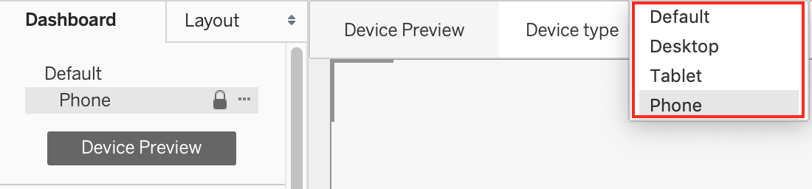

**Reference:**<https://help.tableau.com/current/pro/desktop/en-us/dashboards_dsd_create.htm>

Bottom of Form

Top of Form

Question 28: **Correct**

**Broadly speaking, after an importing a dataset in Tableau Desktop, all fields in it are broken down into _______________________**

* 

**Dimensions and Measures**

**(Correct)**

* 

**Numbers and Headers**

* 

**Rows and Columns**

* 

**Labels and Values**

**Explanation**

When you connect to a new data source, Tableau assigns each field in the data source as **dimension or measure** in the Data pane, depending on the type of data the field contains. You use these fields to build views of your data.

Further,

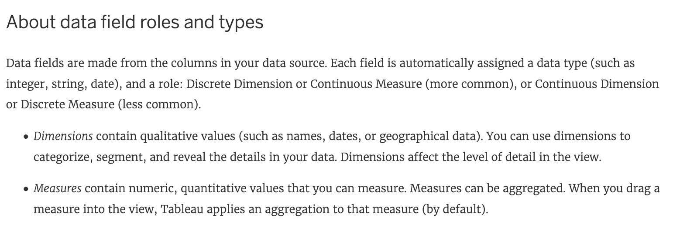

**Reference**: <https://help.tableau.com/current/pro/desktop/en-us/datafields_typesandroles.htm>

Bottom of Form

Top of Form

Question 29: **Correct**

**You can create _____________ for members in a dimension so that their labels appear differently in the view.**

* 

**aliases**

**(Correct)**

* 

**renames**

* 

**duplicates**

* 

**copies**

**Explanation**

You can create **aliases** (alternate names) for members in a dimension so that their labels appear differently in the view.

Aliases can be created for the members of discrete dimensions only. They **cannot** be created for continuous dimensions, dates, or measures.

**From the official documentation -**

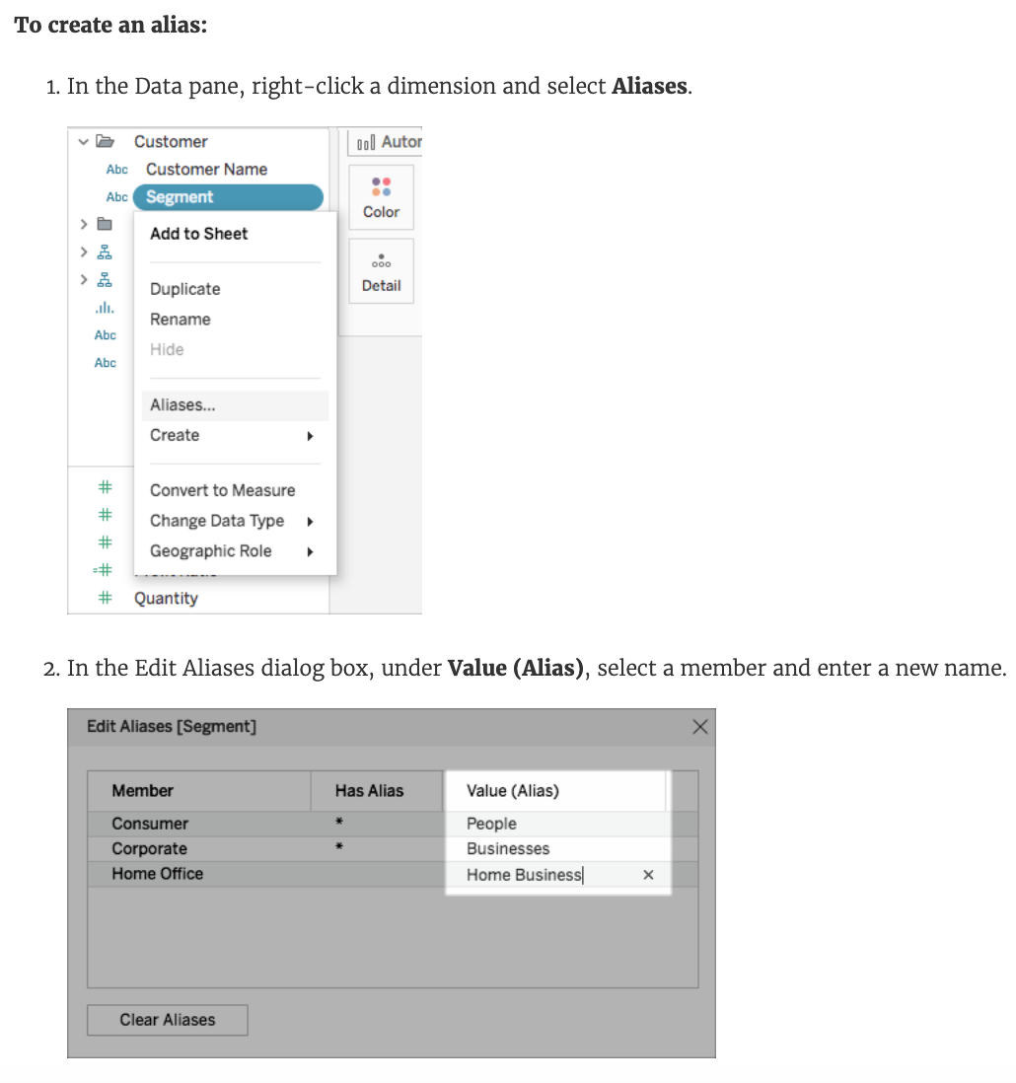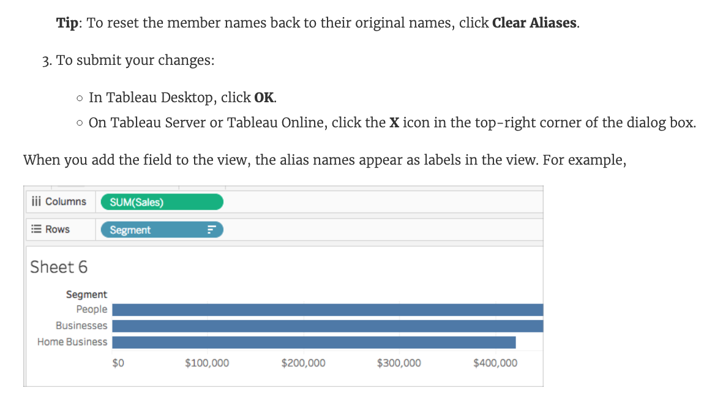

**Note**: While you can't create an alias for a measure, remember that you can rename it when you right-click the field and select **Rename**.

**Reference:** <https://help.tableau.com/current/pro/desktop/en-us/datafields_fieldproperties_aliases_ex1editing.htm>

Bottom of Form

Top of Form

Question 30: **Correct**

**You have just created a histogram and now want to be able to change the size of bins dynamically. Using which of the following will easily satisfy your requirement?**

* 

**Calculation**

* 

**Groups**

* 

**Sets**

* 

**Parameters**

**(Correct)**

**Explanation**

A parameter is a **global placeholder** value such as a number, date, or string that can replace a constant value in a calculation, filter, or reference line.

For example, you may create a calculated field that returns True if Sales is greater than $500,000 and otherwise returns False. You can replace the constant value of “500000” in the formula with a parameter. Then, using the parameter control, you can dynamically change the threshold in your calculation.

**For example -**

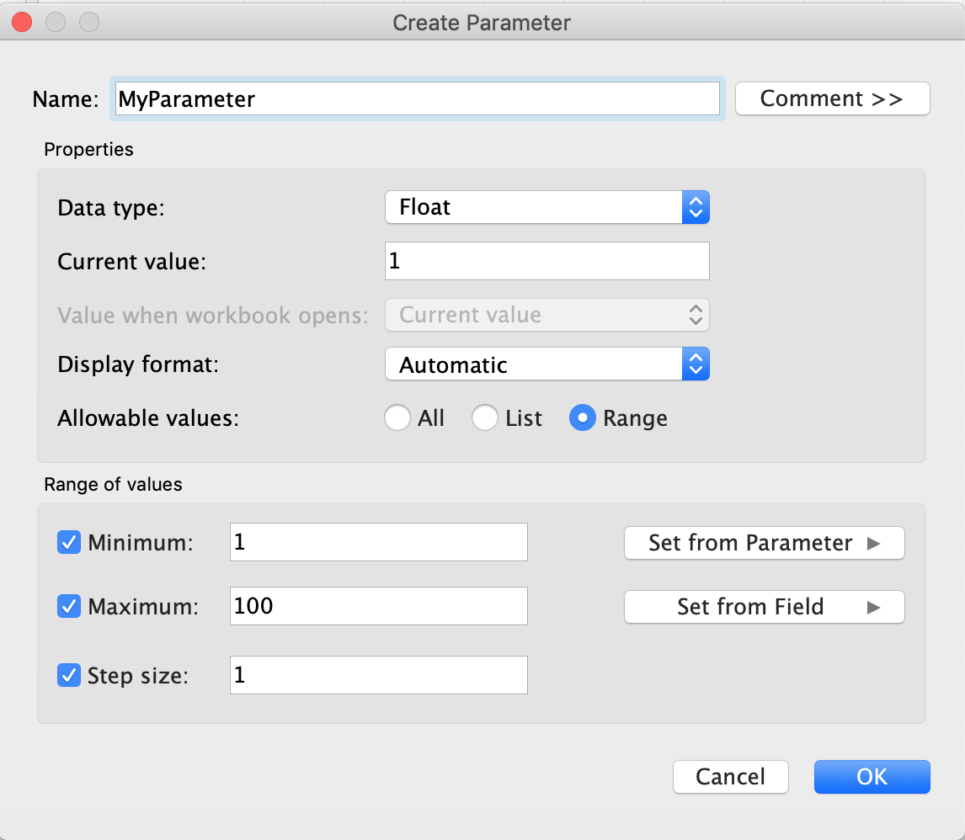

**Reference:**<https://help.tableau.com/current/pro/desktop/en-us/parameters_create.htm>

Bottom of Form

Top of Form

Question 31: **Incorrect**

**True or False: You get different filtering options for categorical and quantitative data**

* 

**True**

**(Correct)**

* 

**False**

**(Incorrect)**

**Explanation**

Yes! We get different options for filtering depending on whether we use a **categorical** data (think dimension) or **quantitative** data (think measure).

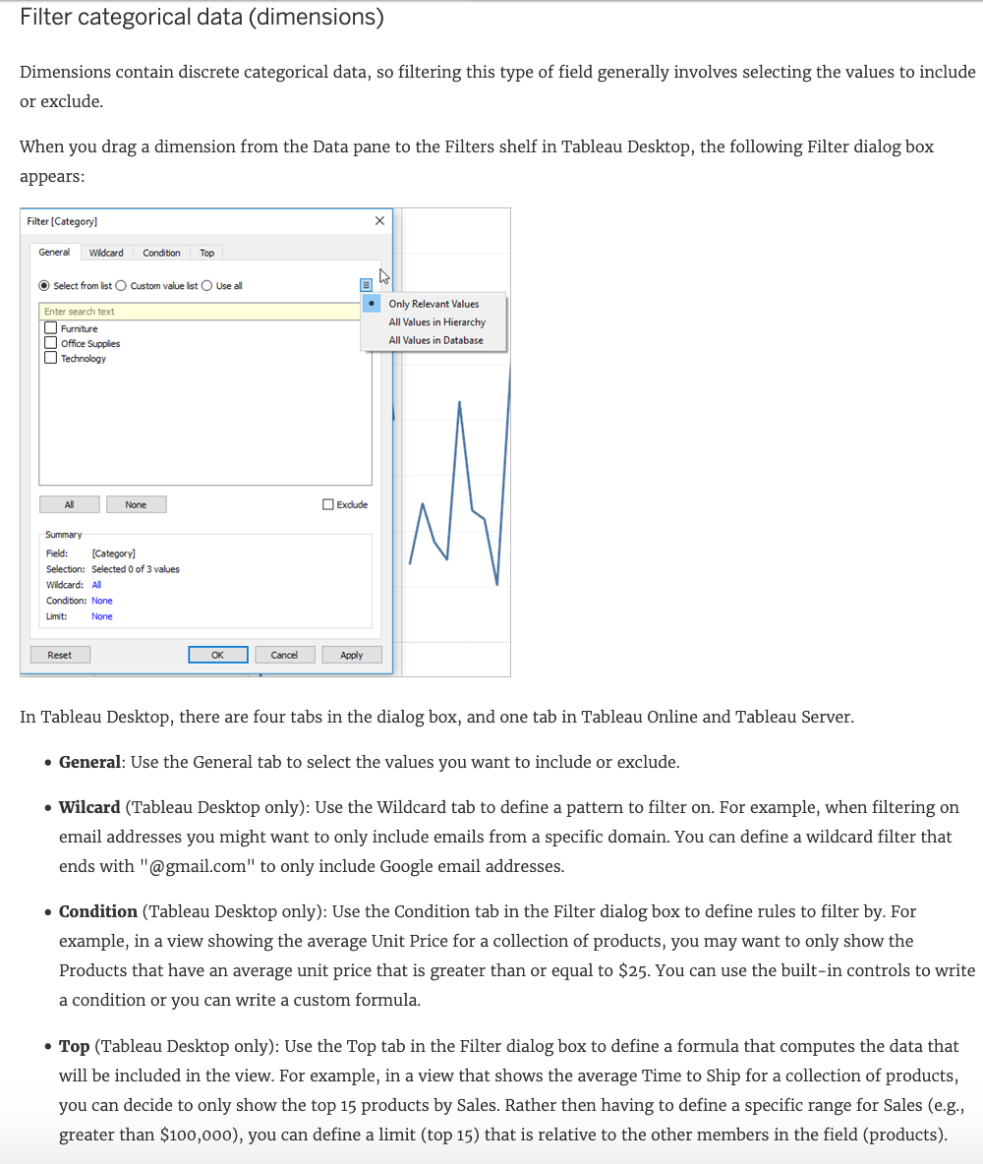

**Important Note**: Each tab adds additional definitions to your filter. For example, you can select to exclude values under the General tab, and also add limits under the Top tab. Selections and configurations from both tabs are applied to your filter.  
At any time, you can see the definitions of your filter under Summary on the General tab.

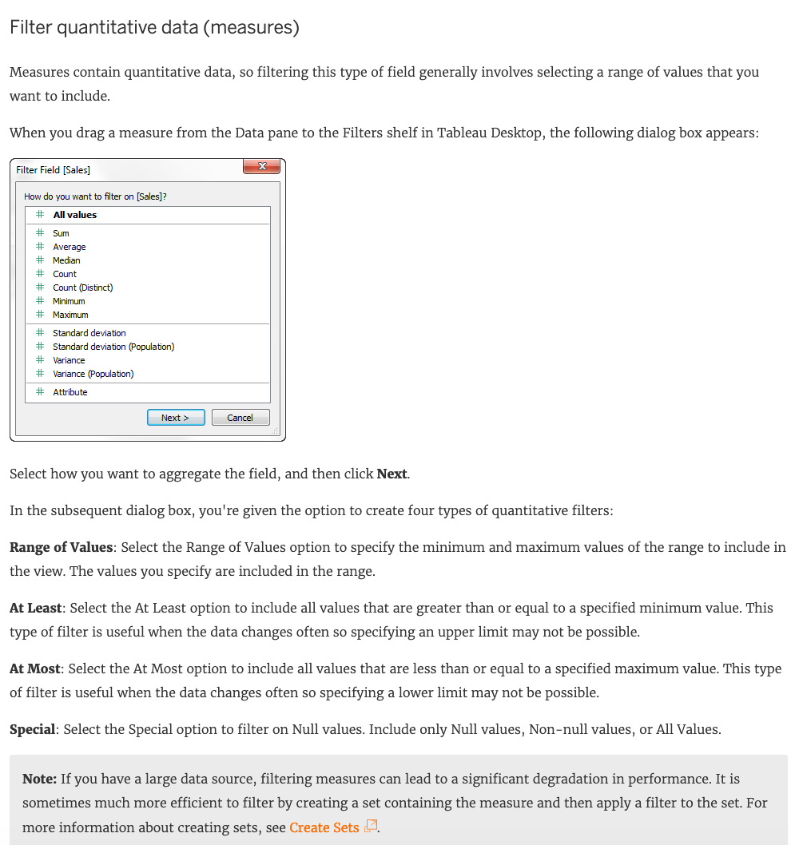

**Note:** If you have a large data source, filtering measures can lead to a significant degradation in performance. It is sometimes much more efficient to filter by creating a set containing the measure and then apply a filter to the set. For more information about creating sets, see [Create Sets](https://help.tableau.com/current/pro/desktop/en-us/sortgroup_sets_create.htm)

**Reference:**<https://help.tableau.com/current/pro/desktop/en-us/filtering.htm>

Bottom of Form

Top of Form

Question 32: **Correct**

**Which of the following are valid ways to copy a worksheet visualisation as an image?**

* 

**Using the Marks shelf and choosing Copy->Image**

* 

**By clicking on Worksheet in the Tableau Main Menu above, and choosing Copy->Image**

**(Correct)**

* 

**By right clicking on the worksheet visualisation and selecting Copy->Image**

**(Correct)**

* 

**By simply clicking Control + V on the keyboard**

**Explanation**

**The following are 2 correct ways to copy the worksheet visualisation as an image:**

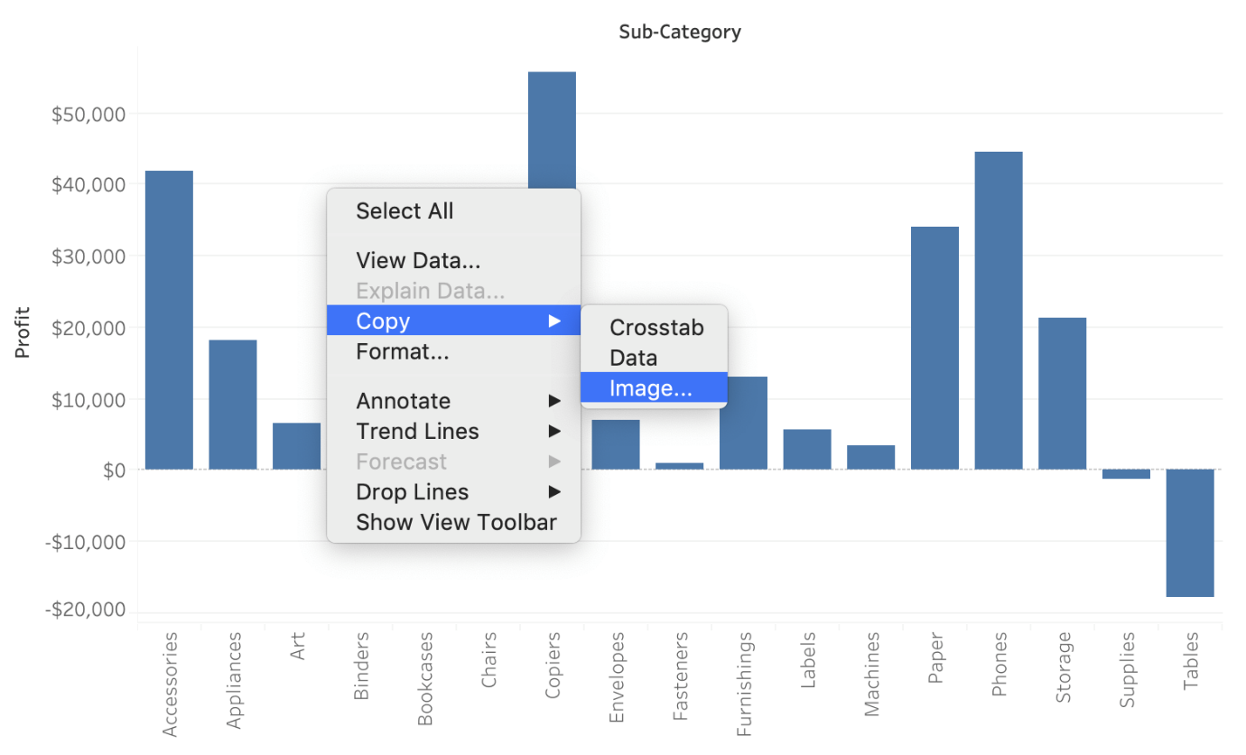

**AND**

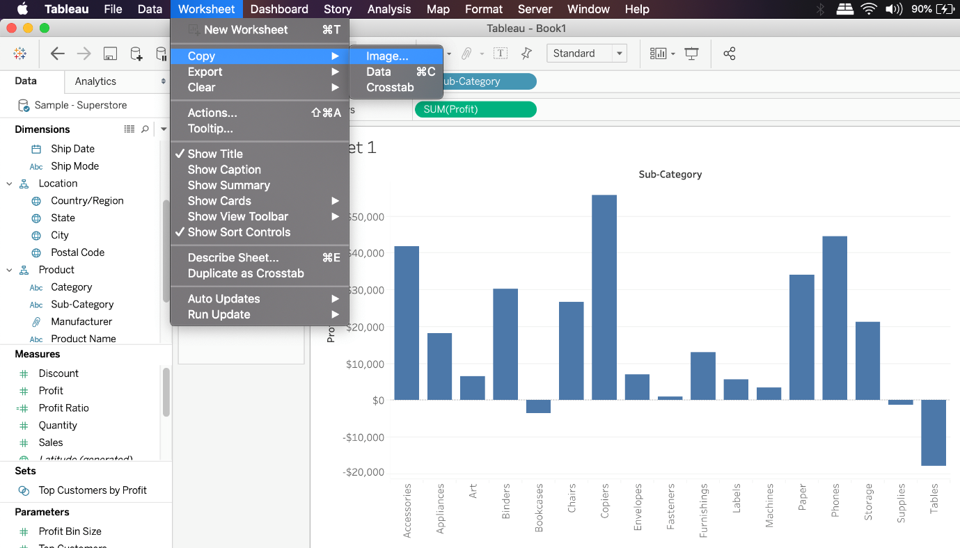

**Reference:**<https://help.tableau.com/current/pro/desktop/en-us/save_export_image.htm>

Bottom of Form

Top of Form

Question 33: **Correct**

**_________________  are a local copy of a subset or entire data set that you can use to share data with others, when you need to work offline, and improve performance.**

* 

**.tbm files**

* 

**.twb files**

* 

**.tde files**

**(Correct)**

* 

**.twbx files**

**Explanation**

**According to the official Tableau documentation:**

Depending on the version the extract was created in, Tableau extract files can have either the .hyper or .tde file extension. Extract files are a local copy of a subset or entire data set that you can use to share data with others, when you need to work offline, and improve performance. For more information, see [Extract Your Data](https://help.tableau.com/current/pro/desktop/en-us/extracting_data.htm).

**Reference:** <https://help.tableau.com/current/pro/desktop/en-us/environ_filesandfolders.htm>

Bottom of Form

Top of Form

Question 34: **Correct**

**Which of the following URL prefixes are permitted when creating a URL Action in Tableau?**

* 

**SMTP**

* 

**FTP**

**(Correct)**

* 

**HTTPS**

**(Correct)**

* 

**HTTP**

**(Correct)**

**Explanation**

A URL action is a **hyperlink** that points to a web page, file, or other web-based resource outside of Tableau. You can use URL actions to create an email or link to additional information about your data. To customize links based on your data, you can automatically enter field values as parameters in URLs.

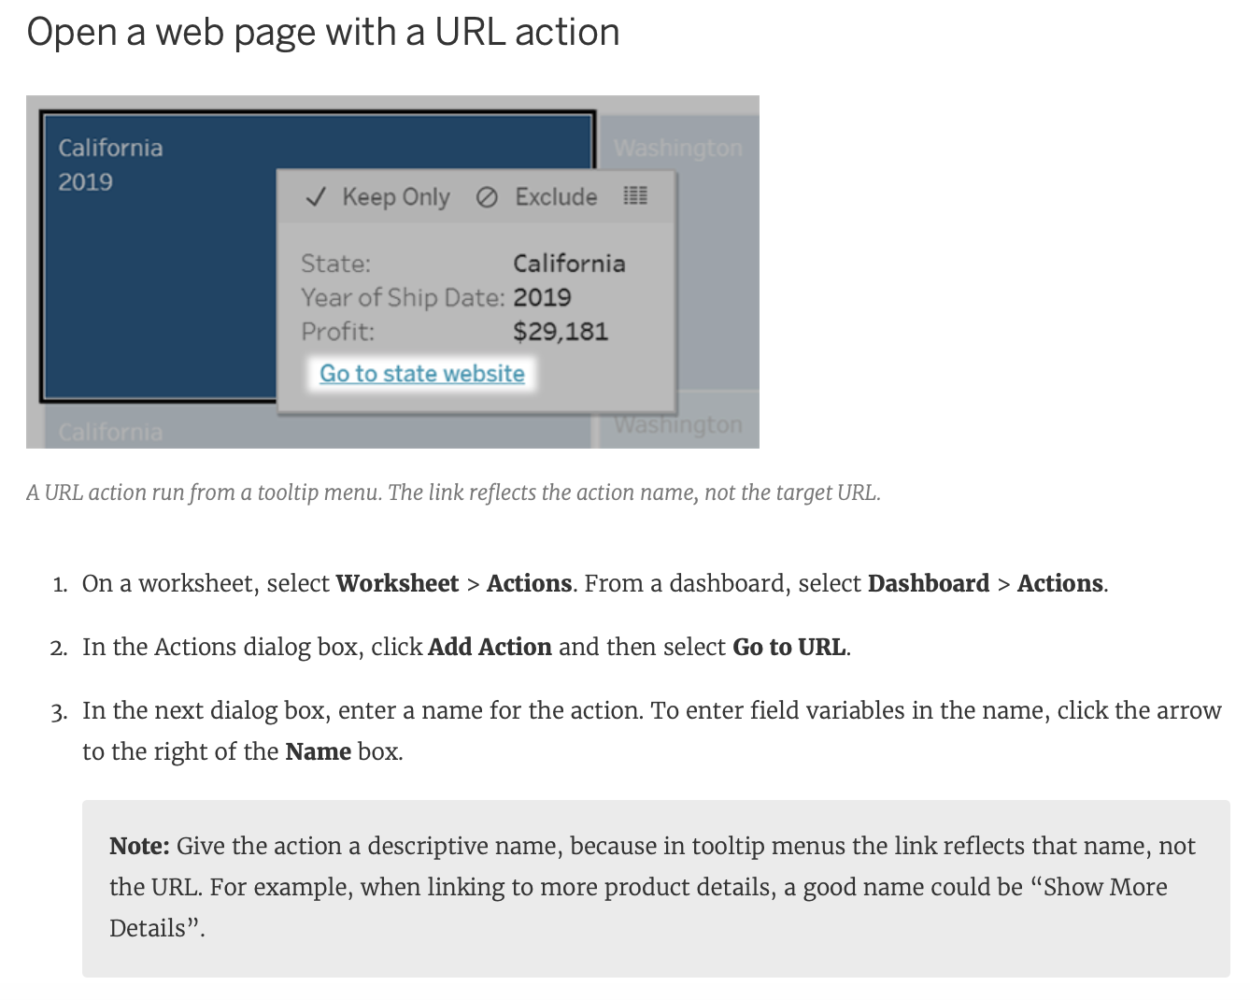

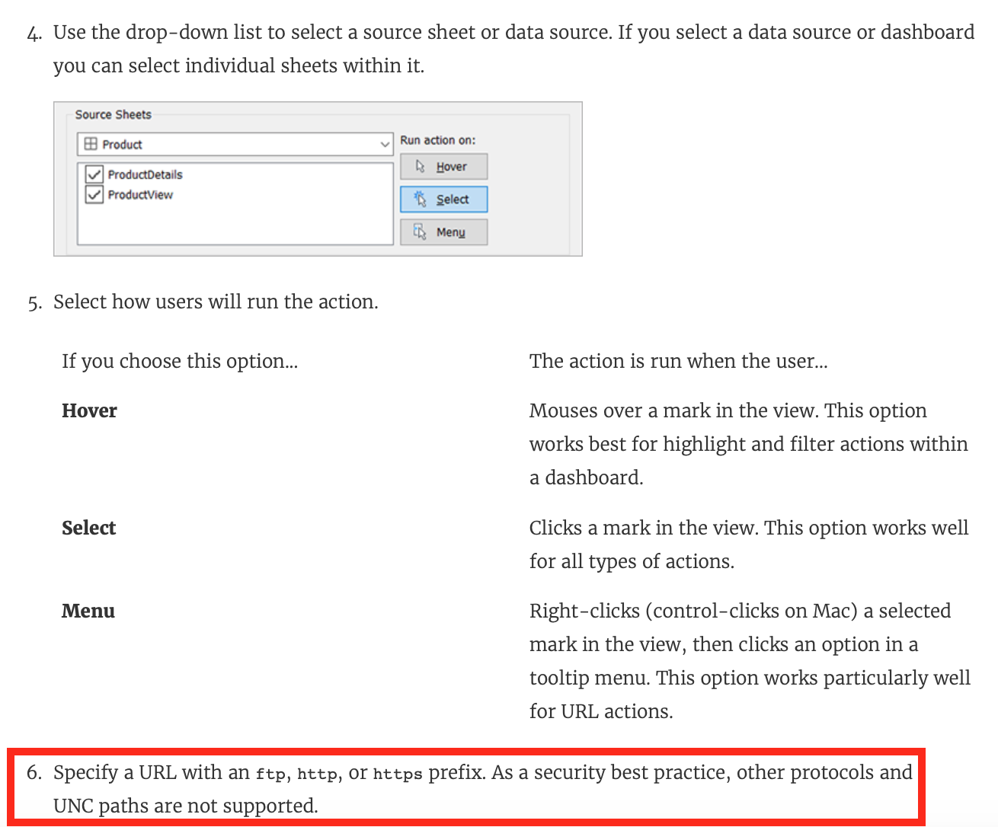

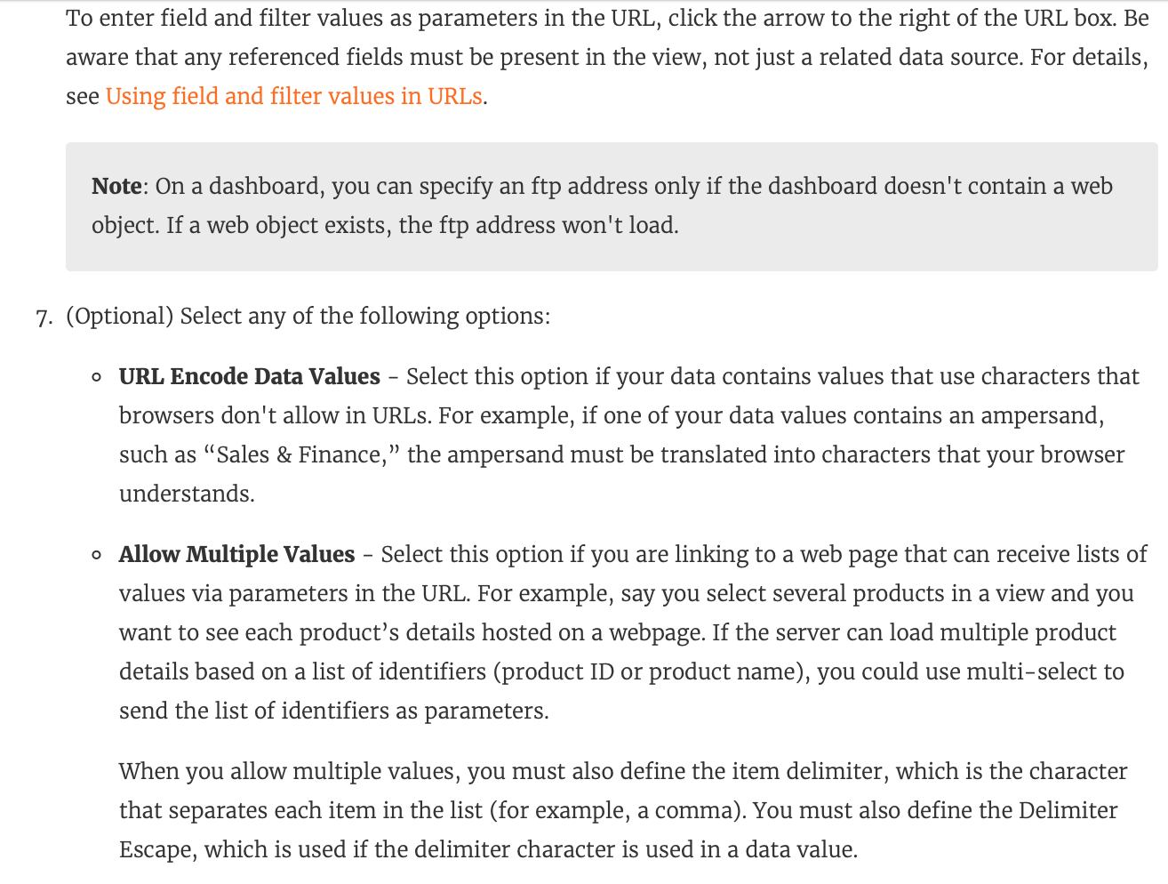

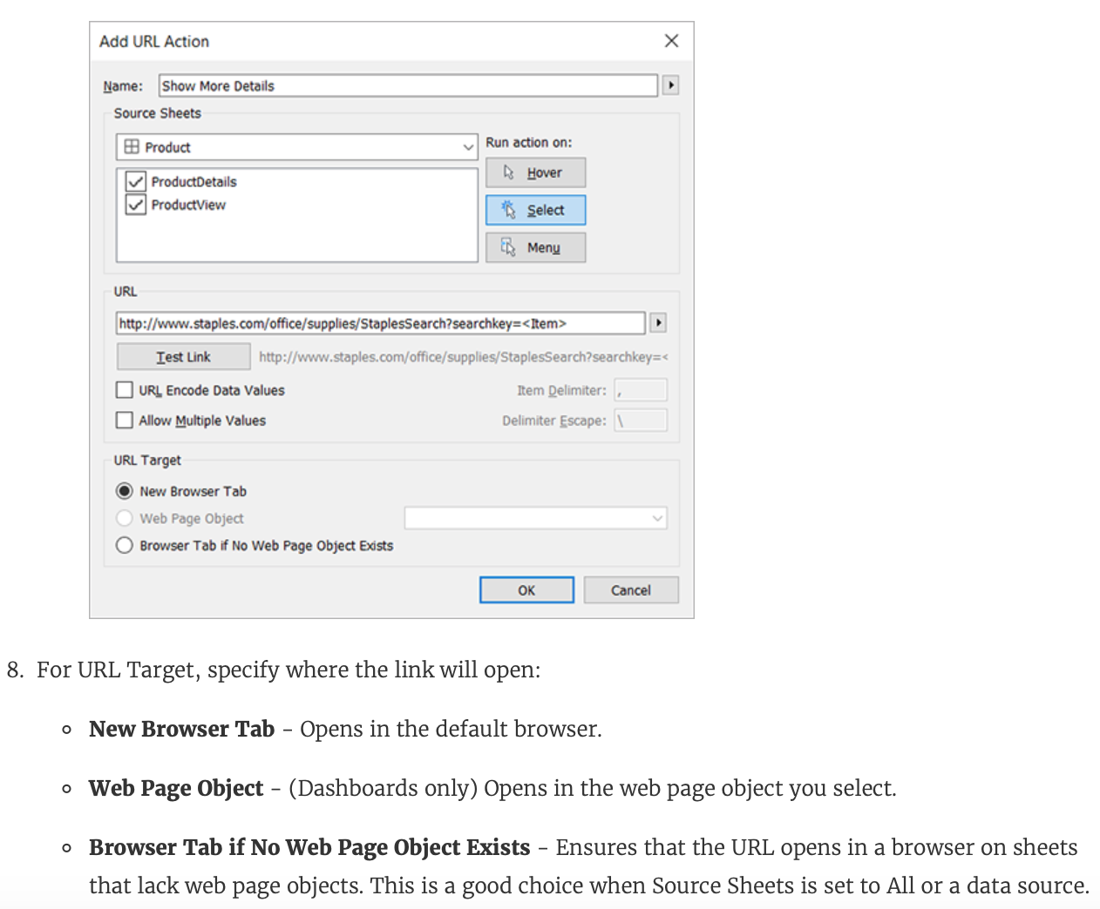

**Reference:**<https://help.tableau.com/current/pro/desktop/en-us/actions_url.htm>

Bottom of Form

Top of Form

Question 35: **Incorrect**

**What is the following icon in the Data pane used to do?**



* 

**View Data**

**(Correct)**

* 

**Clean Data**

* 

**Sort Data**

**(Incorrect)**

* 

**Extract Data**

**Explanation**

**View Data** allows you to inspect your data in a spreadsheet-like layout. You can view data either for the data source as a whole, or to see the underlying data for an individual mark or a group of marks. In a worksheet, the rows that you see in the View Data window are always scoped to the current selection or the current view.

The View Data window displays as much of the data as possible by default, up to **10,000 rows**. Field names are shown as column headers and can be dragged and dropped to change their display order. Click a column header to sort the values in that column.

**From the official website:**

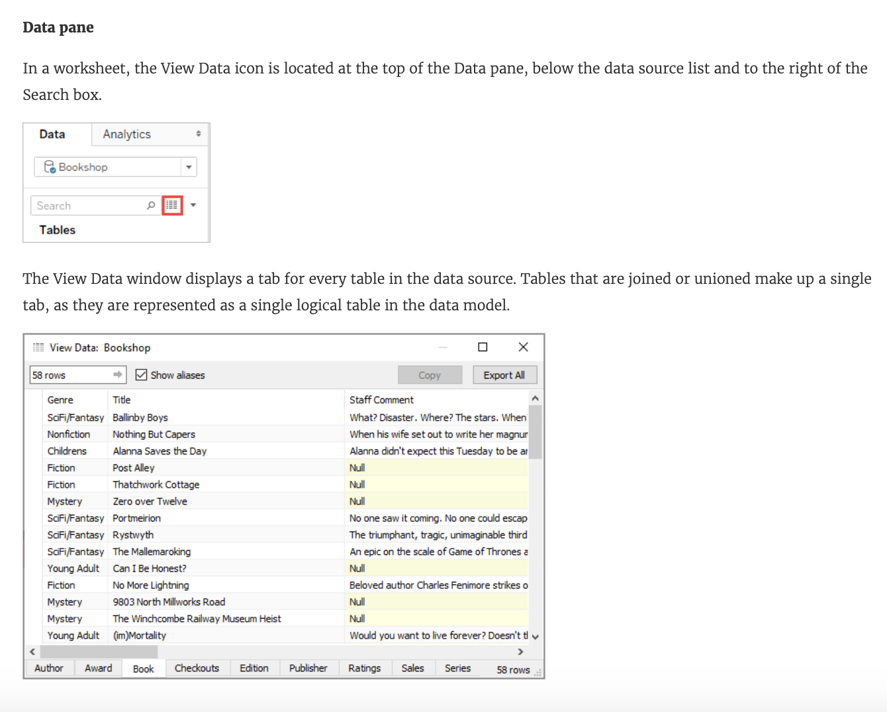

**Reference:**<https://help.tableau.com/current/pro/desktop/en-us/inspectdata_viewdata.htm>

Bottom of Form

Top of Form

Question 36: **Correct**

**What does the following icon do in Tableau?**

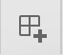

* 

**Create a Worksheet**

* 

**Create a Story and Dashboard both**

* 

**Create a Story**

* 

**Create a Dashboard**

**(Correct)**

**Explanation**

**The icon shown is used to add a new Dashboard! From the official documentation:**

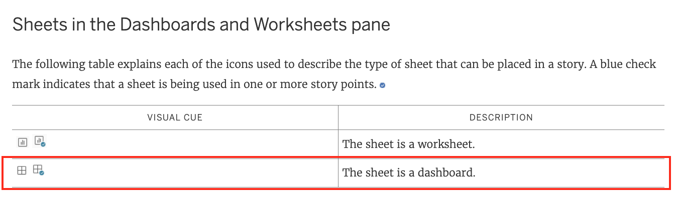

**Reference:** [https://help.tableau.com/current/pro/desktop/en-us/inspectdata_viewdata.htm](https://help.tableau.com/current/pro/desktop/en-us/tips_visualcues.htm)

Bottom of Form

Top of Form

Question 37: **Correct**

**A ________________ is a single zip file that contains a workbook along with any supporting local file data and background images. This format is the best way to package your work for sharing with others who don’t have access to the original data.**

* 

**.twb file**

* 

**.tde file**

* 

**.tbm file**

* 

**.twbx file**

**(Correct)**

**Explanation**

**According to the official Tableau documentation:**

Tableau packaged workbooks have the .twbx file extension. A packaged workbook is a single zip file that contains a workbook along with any supporting local file data and background images. This format is the best way to package your work for sharing with others who don’t have access to the original data. For more information, see [Packaged Workbooks](https://help.tableau.com/current/pro/desktop/en-us/save_savework_packagedworkbooks.htm).

**Reference:**<https://help.tableau.com/current/pro/desktop/en-us/environ_filesandfolders.htm>

Bottom of Form

Top of Form

Question 38: **Correct**

**In Tree maps, the size begins with the largest rectangle on the ________________ and the smallest rectangle on the ________________.**

* 

**top right, bottom left**

* 

**top right, bottom right**

* 

**top left bottom left**

* 

**top left, bottom right**

**(Correct)**

**Explanation**

**Tree maps size begins from maximum in top left to smallest in bottom right.**

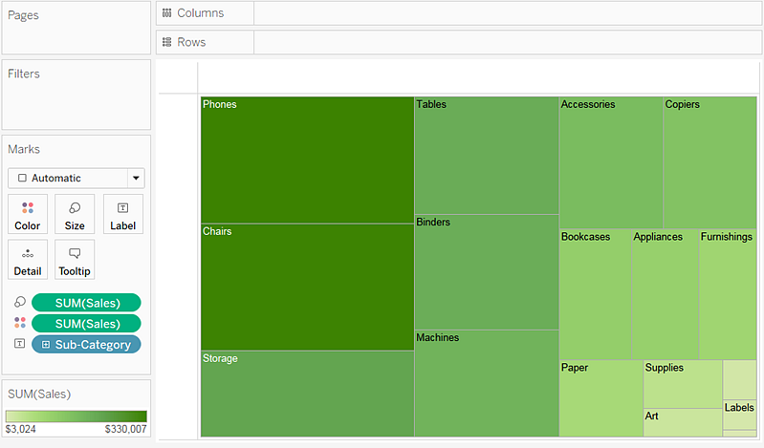

**See below to learn how to create a TreeMap and add colours to it:**



**Reference:**<https://help.tableau.com/current/pro/desktop/en-us/buildexamples_treemap.htm>

Bottom of Form

Top of Form

Question 39: **Correct**

**How does Tableau know at which level to aggregate values?**

* 

**Tableau doesn't aggregate values, we do!**

* 

**Values are always aggregated at the level of granularity of the worksheet.**

**(Correct)**

* 

**Aggregation is always done by using Tableau special formulas**

* 

**Values are always aggregated at the level of the Date Part**

**Explanation**

In Tableau, you can aggregate measures or dimensions, though it is more common to aggregate measures. Whenever you add a measure to your view, an aggregation is applied to that measure by default. The type of aggregation applied varies **depending on the context of the view.**

When you add a measure to the view, Tableau automatically aggregates its values. Sum, average, and median are common aggregations; for a complete list, see [List of Predefined Aggregations in Tableau](https://help.tableau.com/current/pro/desktop/en-us/calculations_aggregation.htm#AggFuncs).

The current aggregation appears as part of the measure's name in the view. For example, Sales becomes SUM(Sales). Every measure has a default aggregation which is set by Tableau when you connect to a data source. You can view or change the default aggregation for a measure—see [Set the Default Aggregation for a Measure](https://help.tableau.com/current/pro/desktop/en-us/calculations_aggregation.htm#DefaultAgg).

You can change the aggregation for a measure in the view from its **context menu:**

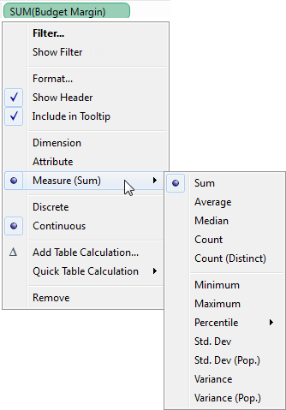

**Reference:** <https://help.tableau.com/current/pro/desktop/en-us/calculations_aggregation.htm>

Bottom of Form

Top of Form

Question 40: **Correct**

**________________  files are shortcuts for quickly connecting to the original data that you use often. Data source files do not contain the actual data but rather the information necessary to connect to the actual data as well as any modifications you've made on top of the actual data such as changing default properties, creating calculated fields, adding groups, and so on.**

* 

**.tde**

* 

**.tbm**

* 

**.tds**

**(Correct)**

* 

**.twb**

**Explanation**

**According to the official Tableau documentation:**

**Tableau data source** files have the .tds file extension. Data source files are shortcuts for quickly connecting to the original data that you use often. Data source files do not contain the actual data but rather the information necessary to connect to the actual data as well as any modifications you've made on top of the actual data such as changing default properties, creating calculated fields, adding groups, and so on. For more information, see [Save Data Sources](https://help.tableau.com/current/pro/desktop/en-us/export_connection.htm).

**Reference:** <https://help.tableau.com/current/pro/desktop/en-us/environ_filesandfolders.htm>

Bottom of Form

Top of Form

Question 41: **Incorrect**

**Which of the following are valid ways of Grouping Data?**

* 

**Using Marks in the view**

**(Correct)**

* 

**From the Analytics Pane**

**(Incorrect)**

* 

**Using Labels in the View**

**(Correct)**

* 

**From the Dimensions Shelf**

**(Correct)**

**Explanation**

**\*\*IMPORTANT QUESTION AND EXPLANATION, PLEASE READ\*\***

**3 ways to group data -**

1) Marks

2) Labels

3) Dimensions shelf.

**\*IMPORTANT\***

If we Group the data by selecting the marks, then they remain **separate marks** in the view and then have the same colour. Also, a new group is created in the Dimensions shelf. Example -

**Using the sample superstore dataset, first plot a bar chart showing sales for each sub-category:**

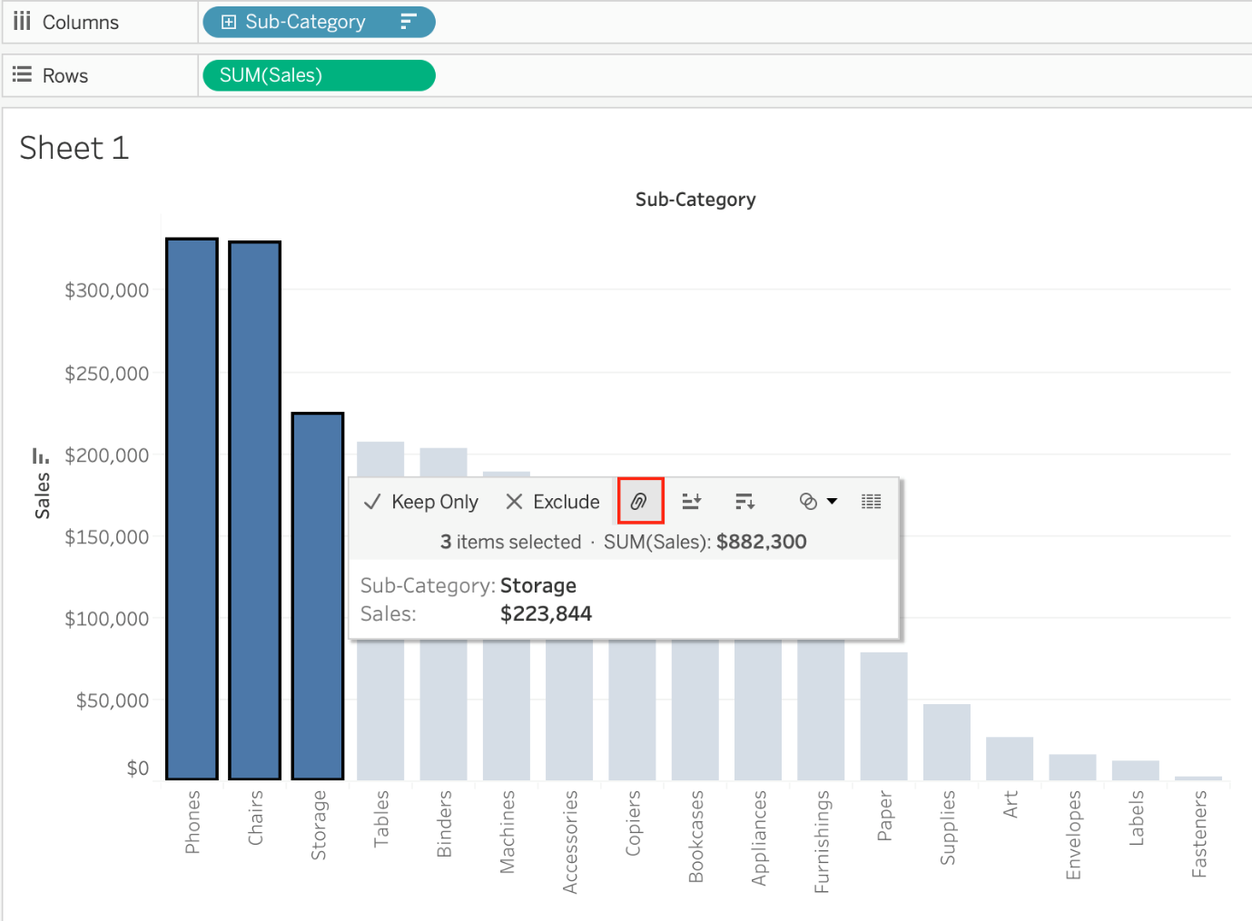

Here, if we Select Phones, Chairs and Storage by selecting the **MARKS (Bars), and then group them:**

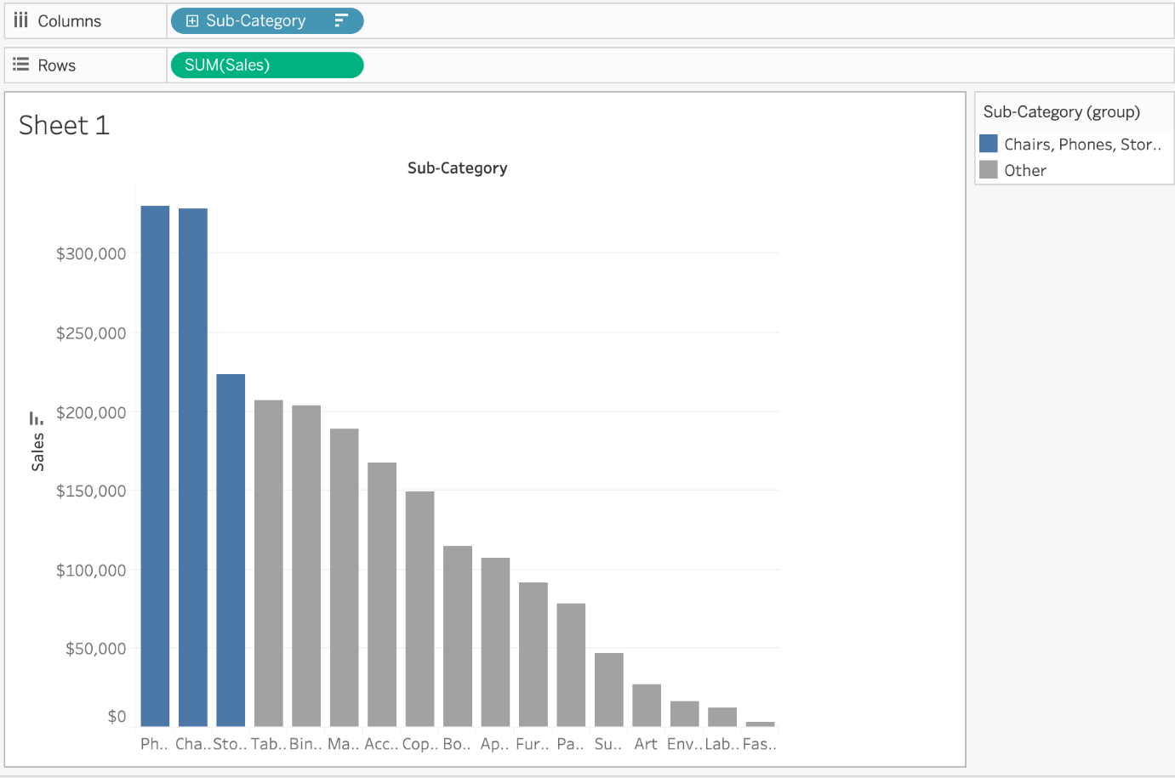

**They remain seperate marks (BARS) but are grouped by the same colour.**

Now, if we didn't do this, and rather grouped by selecting their **Labels** (Names):

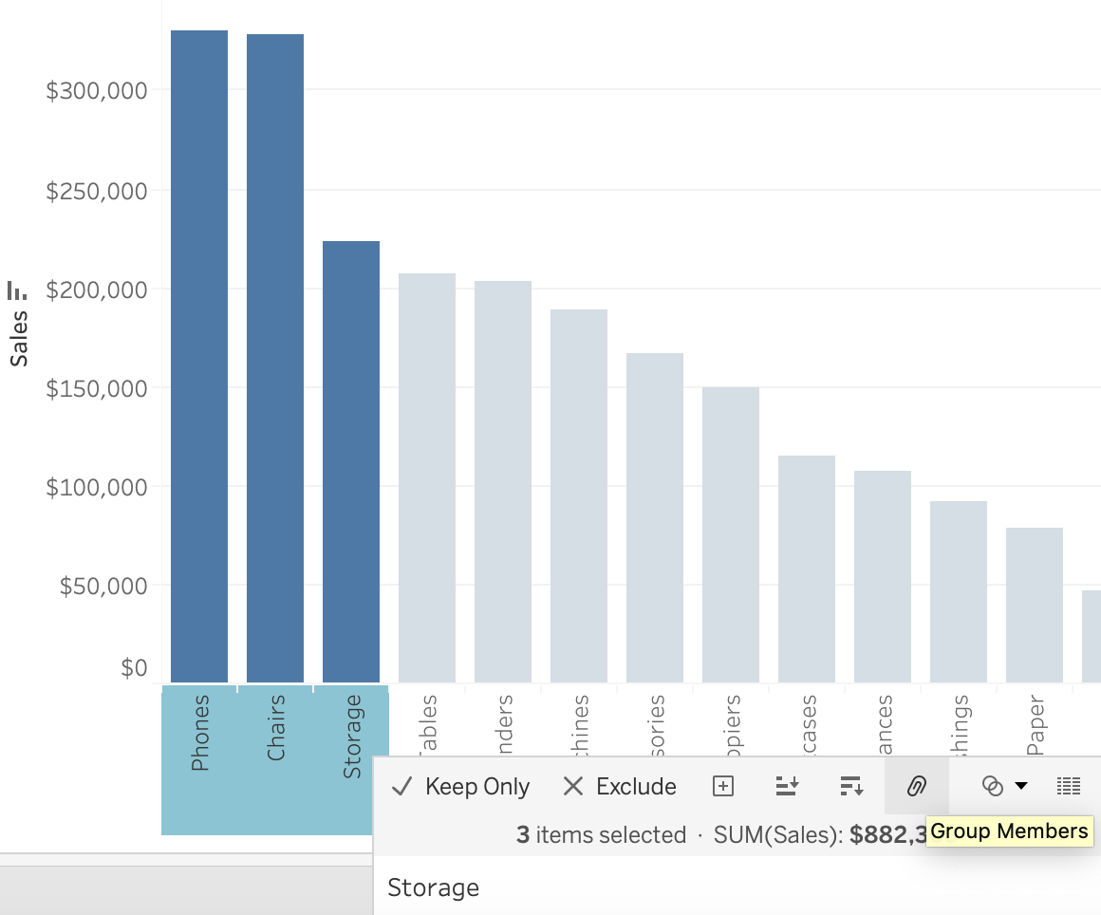

**Then they no longer remain separate Marks (bars) but are rather consolidated into a single Bar:**

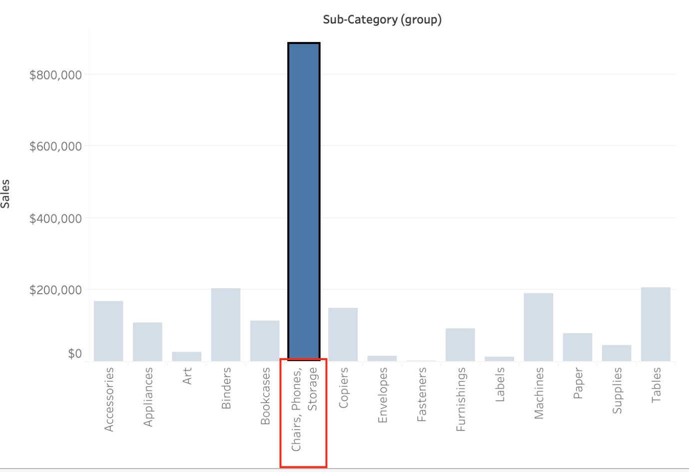

Finally, we can group directly from the **Dimensions** shelf as follows:

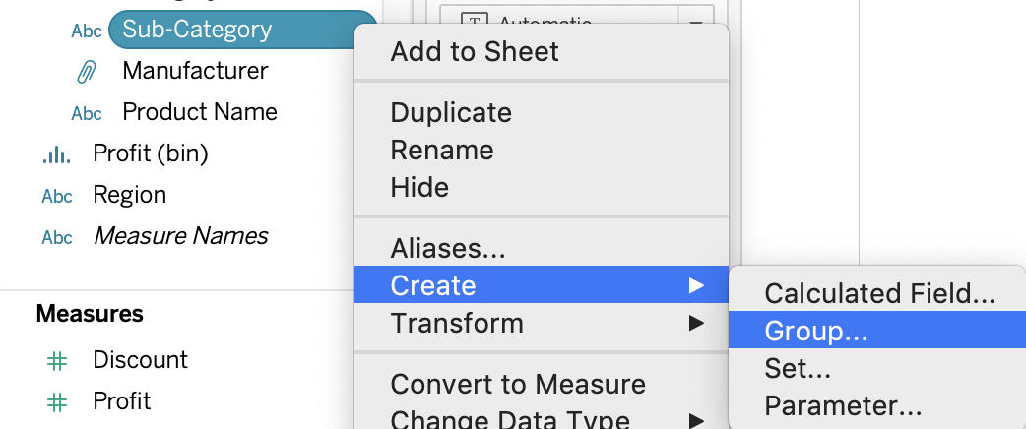

Now choose Phones, Chairs and Storage and **Click Group:**

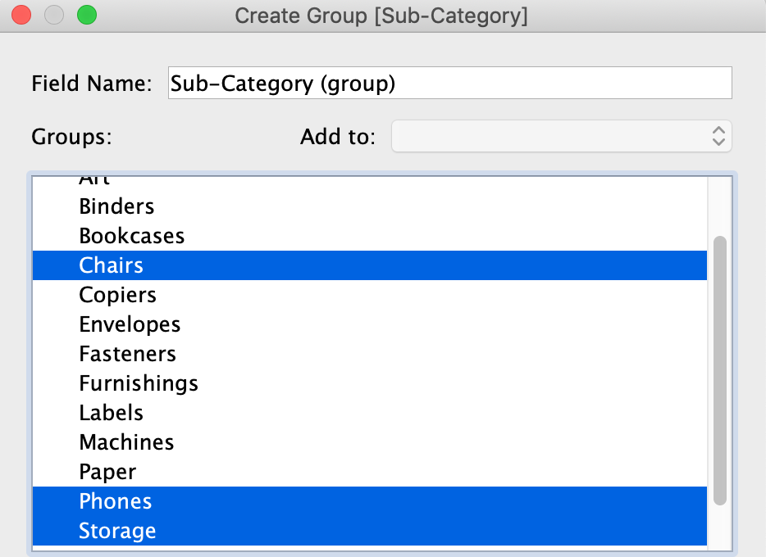

You will now automatically have a new Dimension as follows:



**Reference:**<https://help.tableau.com/current/pro/desktop/en-us/sortgroup_groups_creating.htm>

Bottom of Form

Top of Form

Question 42: **Correct**

**Which of the following is a valid way to create Sets in Tableau?**

* 

**In the Tableau Main Menu, choose Dashboard and select Create > Set**

* 

**In the Data pane, right-click a measure and select Create > Set.**

* 

**In the Data pane, right-click a dimension and select Create > Set.**

**(Correct)**

* 

**In the Tableau Main Menu, Choose Worksheet and select Create > Set**

**Explanation**

There are two types of sets: **dynamic sets and fixed sets.** The members of a dynamic set change when the underlying data changes. Dynamic sets can only be based on a single dimension.

**To create a dynamic set:**

1) In the Data pane, right-click a dimension and select Create > Set.

2) In the Create Set dialog box, configure your set. You can configure your set using the following tabs:

**General**: Use the General tab to select one or more values that will be considered when computing the set.

You can alternatively select the Use all option to always consider all members even when new members are added or removed.

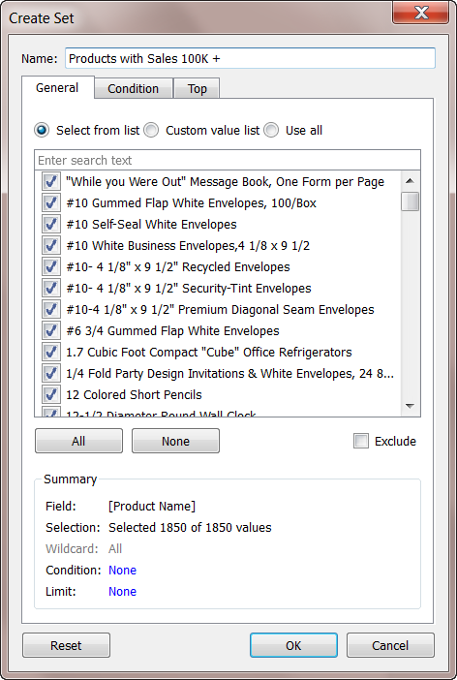

None of the other options exist, and therefore are incorrect answers.

**Reference:** <https://help.tableau.com/current/pro/desktop/en-us/sortgroup_sets_create.htm>

Bottom of Form

Top of Form

Question 43: **Correct**

**Which of the following is NOT a valid official data source in Tableau Desktop?**

* 

**SAP HANA**

* 

**Amazon Redshift**

* 

**PostgreSQL**

* 

**Google Firebase**

**(Correct)**

**Explanation**

Presently, there is no **official** way to connect your data in **Firebase** directly with **Tableau Desktop.**

A workaround however can be to export your Firebase data into **Google BigQuery**, and then connect it to Tableau Desktop.

But then again, it is a workaround and not an official out-of-the-box solution.

The following are the available Data sources available as of now:

**1) Server**

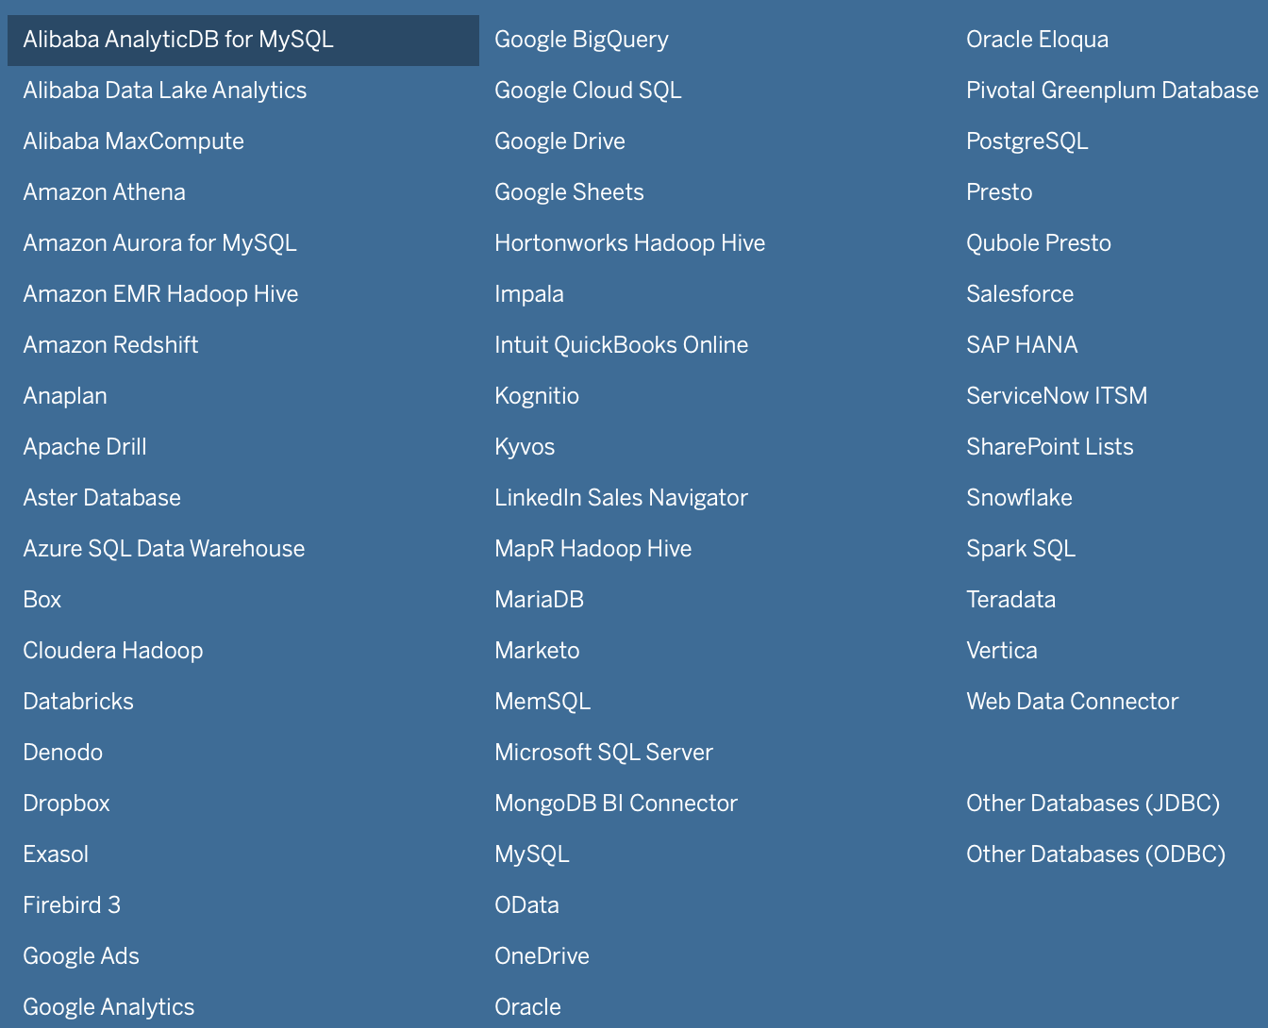

**2) File**

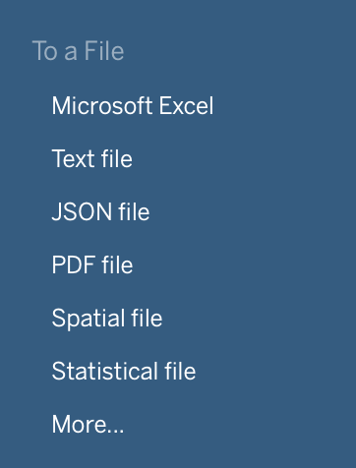

Bottom of Form

Top of Form

Question 44: **Correct**

**How can you change the Default Aggregation for a measure in Tableau?**

* 

**By double clicking on the measure, and then choosing Window -> Default Aggregation**

* 

**By right clicking the measure -> Default properties and choosing Aggregation**

**(Correct)**

* 

**By right clicking the dimension -> Default properties and choosing Aggregation**

* 

**By changing its properties manually every time we need to use it**

**Explanation**

**According to the official Tableau documentation:**

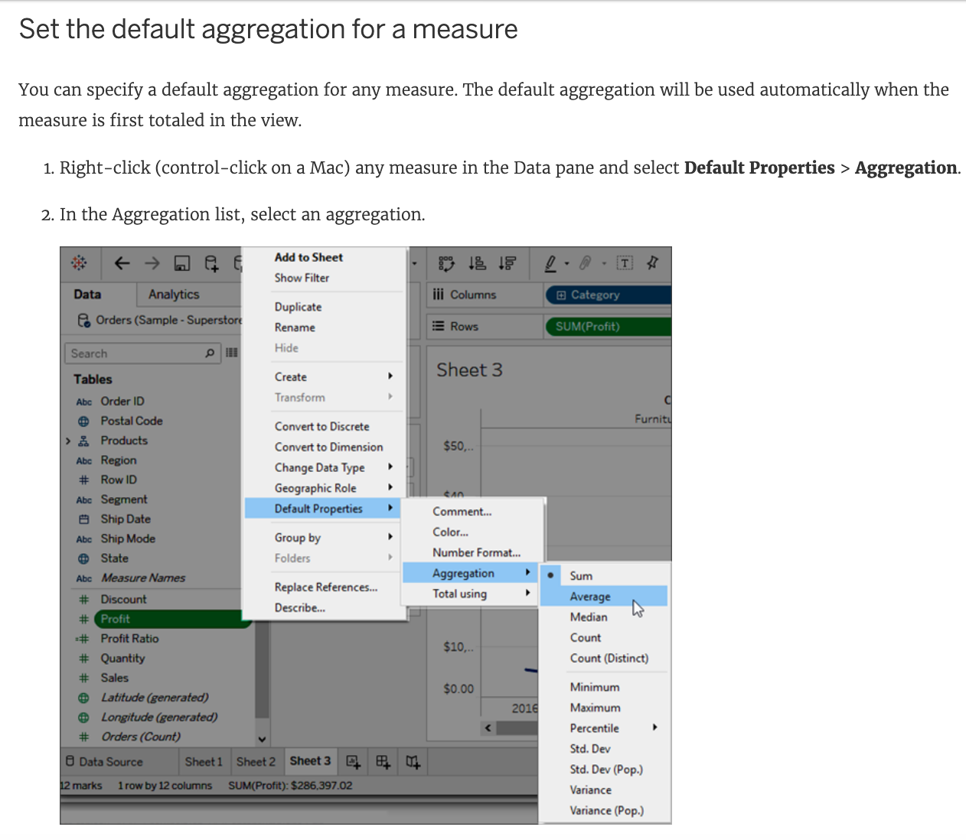

Dimensions don't have aggregation properties, and adding properties manually each time defeats the whole DEFAULT aggregation purpose. Window tab doesn't have any default aggregation option!

**Reference:**<https://help.tableau.com/current/pro/desktop/en-us/datafields_fieldproperties.htm>

Bottom of Form

Top of Form

Question 45: **Incorrect**

**If you see the following Filter, then you're working with _______________________**

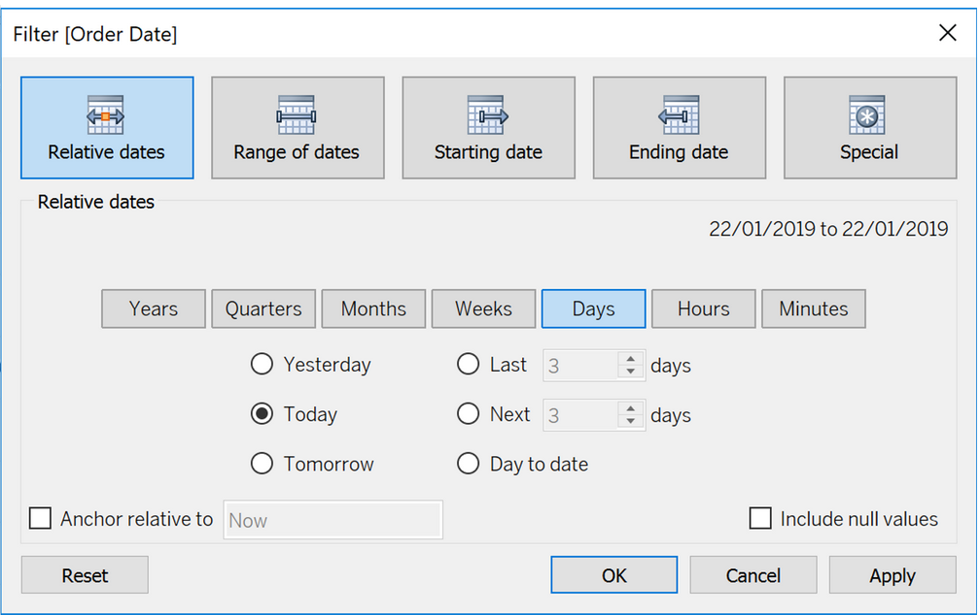

* 

**Grouped Dates**

* 

**Date Functions**

* 

**Date Parts**

**(Incorrect)**

* 

**Date Values**

**(Correct)**

**Explanation**

Dates in Tableau will behave differently depending on whether they are a **Datepart (blue)** or a **Datevalue (green)**. This affects how the axes display/behave and also how visualisations such as line charts will display. The difference essentially boils down to Dateparts behaving like a dimension as opposed to a measure which is how Datevalues behave. This means that Dateparts behave like discrete categories on the view whereas Datevalues are more like continuous numeric values.

**Dateparts** are discrete and they behave the same as dimension filters. If all dates are used on the filter then each individual date will be a datepart that can be selected/excluded. This is the same for each level of date, if datepart months is placed on filters January to December will be tick-able options in the filter. This also means that conditions and top/bottom filters can be applied to datepart filters like any other dimension filter.

**Datevalues** placed on filters behave like measure filters. A min and a max date can be set and there is a relative dates option which allows you to choose things like only show the previous 3 months or years etc.

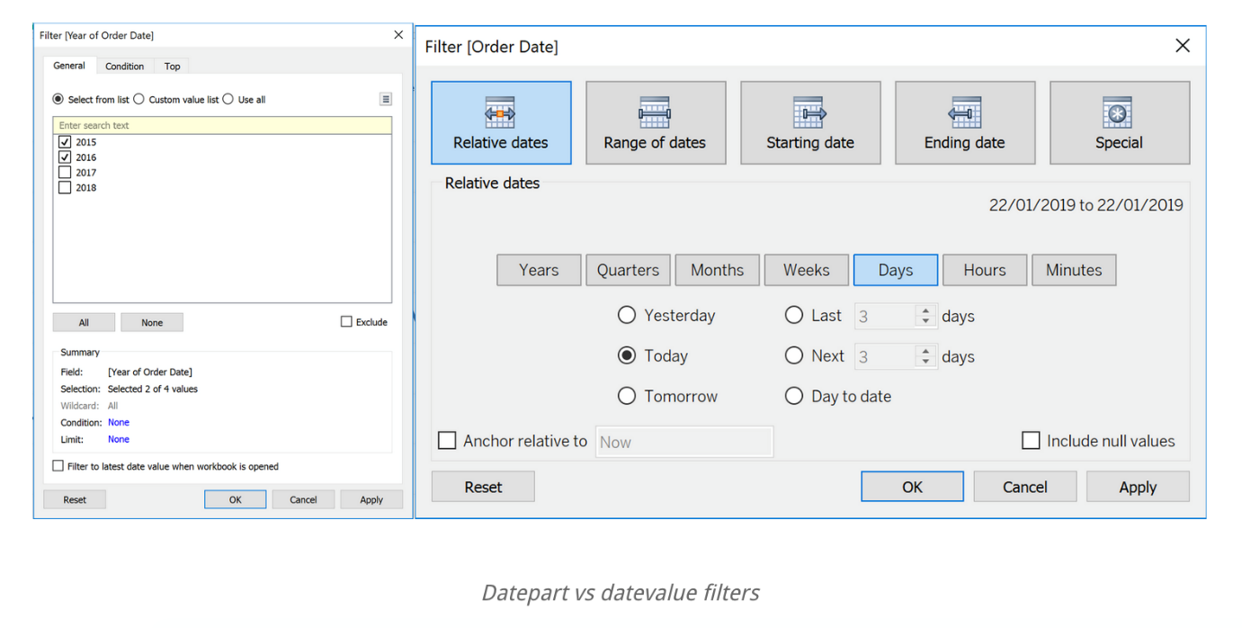

**Reference:**<https://www.thedataschool.co.uk/harry-cooney/tableau-dateparts-vs-datevalues/>

Bottom of Form